**Cricket Score Analysis**

**By Sritha Darbha**

**Question :** Harsha, a Cricket commentator, wants to know which players have played over 200 matches and have a highest score of 150 or above. Write a Spark SQL query using Cloudera or use data bricks?

*import org.apache.spark.sql.functions.col*

*import org.apache.spark.sql.functions.regexp_replace*

*var cricket_hs = spark.sql("select * from cricket_csv")*

*var score = cricket_hs.withColumn("HS",regexp_replace(col("HS"), "\\*", ""))*

*val cricketwout = score.withColumn("HS",col("HS").cast("int"))*

*cricketwout.filter(cricketwout("Mat") > 200 && cricketwout("HS") >= 150).show()*

Import the libraries and upload the cricket table into Databricks. Then, for the High Score column, replace the * with empty space and convert it into integer using the cast function. Using the filter function, filter out the matches more than 200 and with High Score greater than or equal to 150 runs.

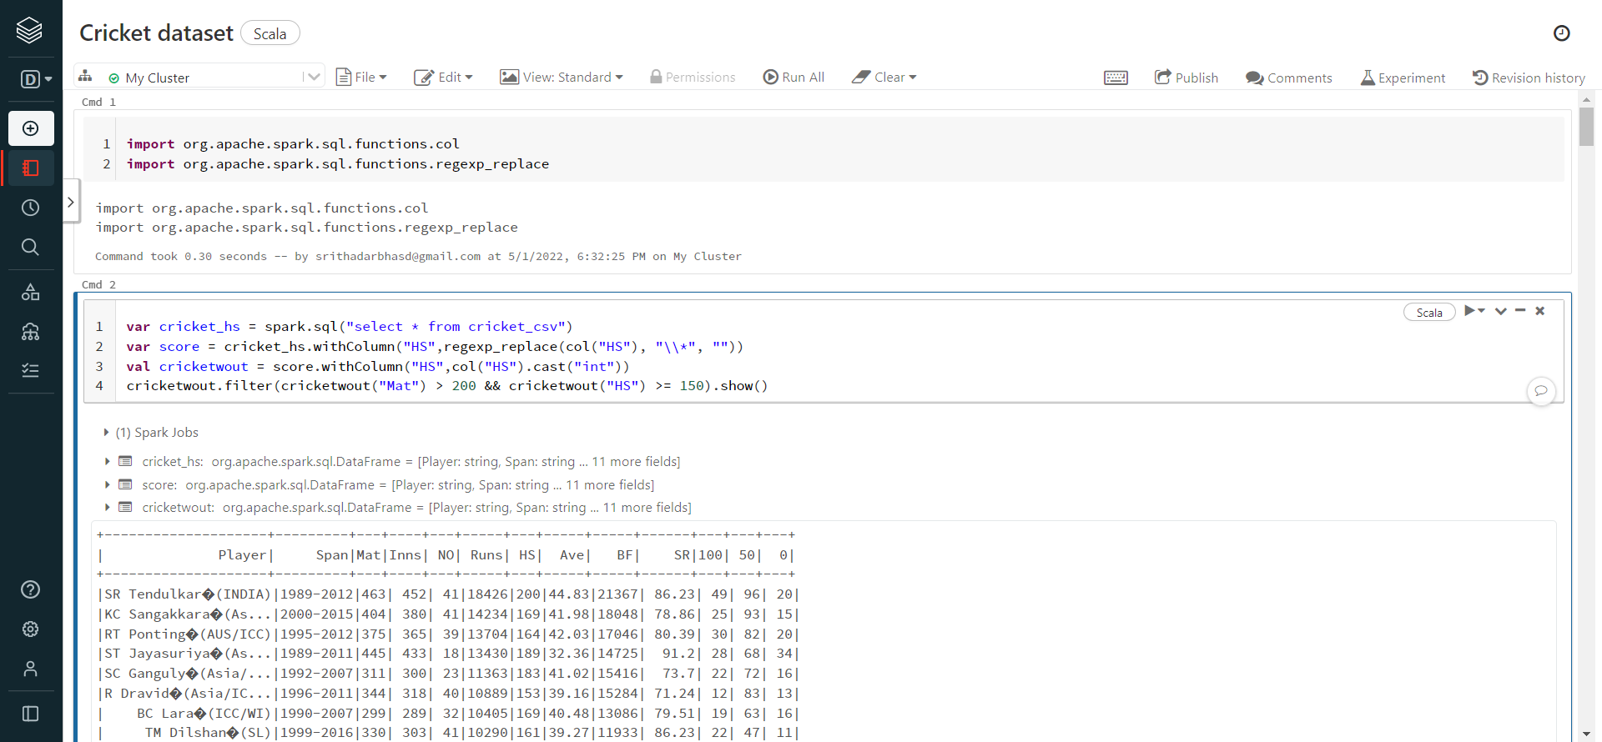

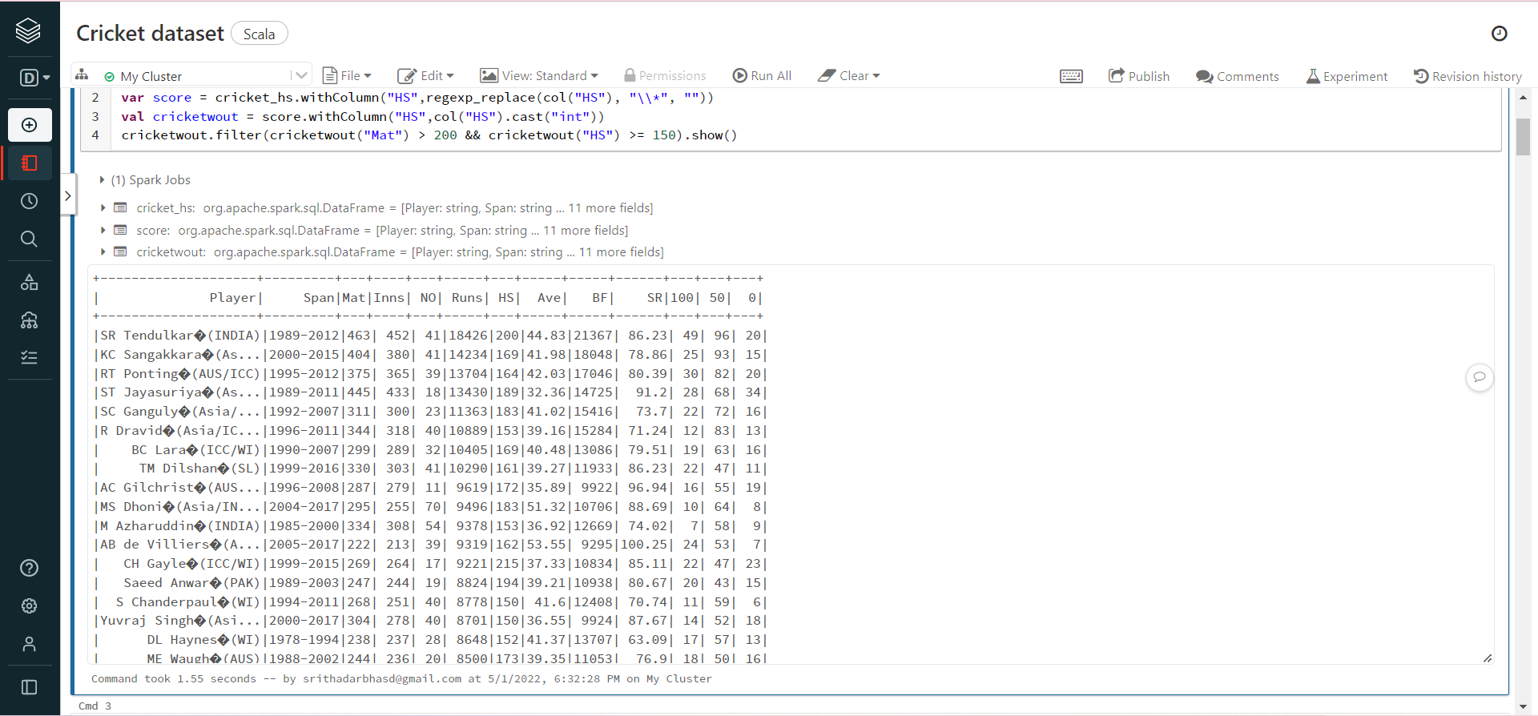

**Question :** Create a column named “Category” based on runs scored. Divide the cricketers into 5 (5000-5999 , 6000-6999, 7000-7999, 8000-8999, 9000 & above) categories. Display Cricketer’s name, strike rate, and Average. With minimum number of matches played and maximum number of matches played in each category?

*import org.apache.spark.sql.functions._*

*import org.apache.spark.sql.expressions.Window*

val crick = Window.partitionBy("category")

val crick2 = Window.partitionBy("category").orderBy("Mat")

val categDF = cricket.withColumn("category",when((cricket("Runs") < 5999 ), "A").when((cricket("Runs") < 6999 ), "B").when ((cricket("Runs") < 7999 ), "C").when ((cricket("Runs") < 8999 ), "D").when((cricket("Runs") >= 9000 ), "E"))

val crickresult4= categDF.withColumn("row",row_number.over(crick2)).withColumn("min",min(categDF("Mat")).over(crick)).withColumn("max",max(categDF("Mat")).over(crick))

crickresult4.filter(crickresult4("Mat") === crickresult4("min") || crickresult4("Mat") === crickresult4("max")).select("Player","SR","Ave","category","min","max").show()

Import the libraries and upload the cricket table into Databricks. Then, partition the data by adding a column called category based on the number of Runs 5000-5999 , 6000-6999, 7000-7999, 8000-8999, 9000 & above, and show the minimum and maximum number of matches played in each category. Displaying the Cricketer’s Name, strike rate, average and Minimum and Maximum Matches and the Category.

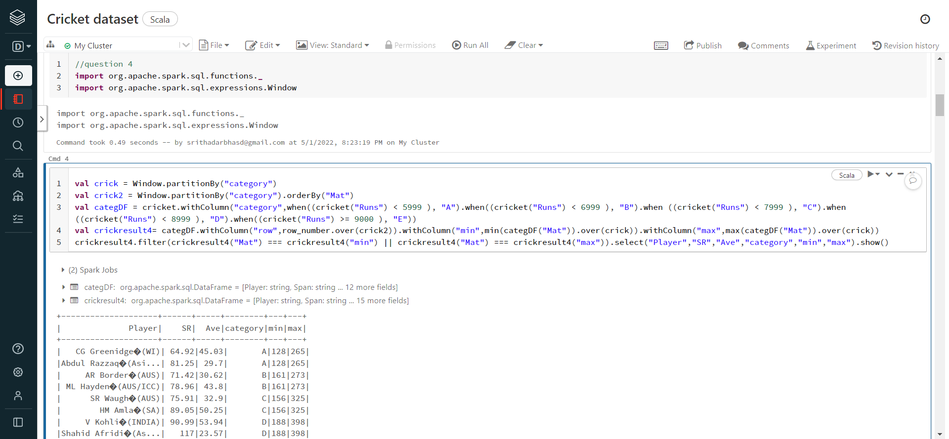

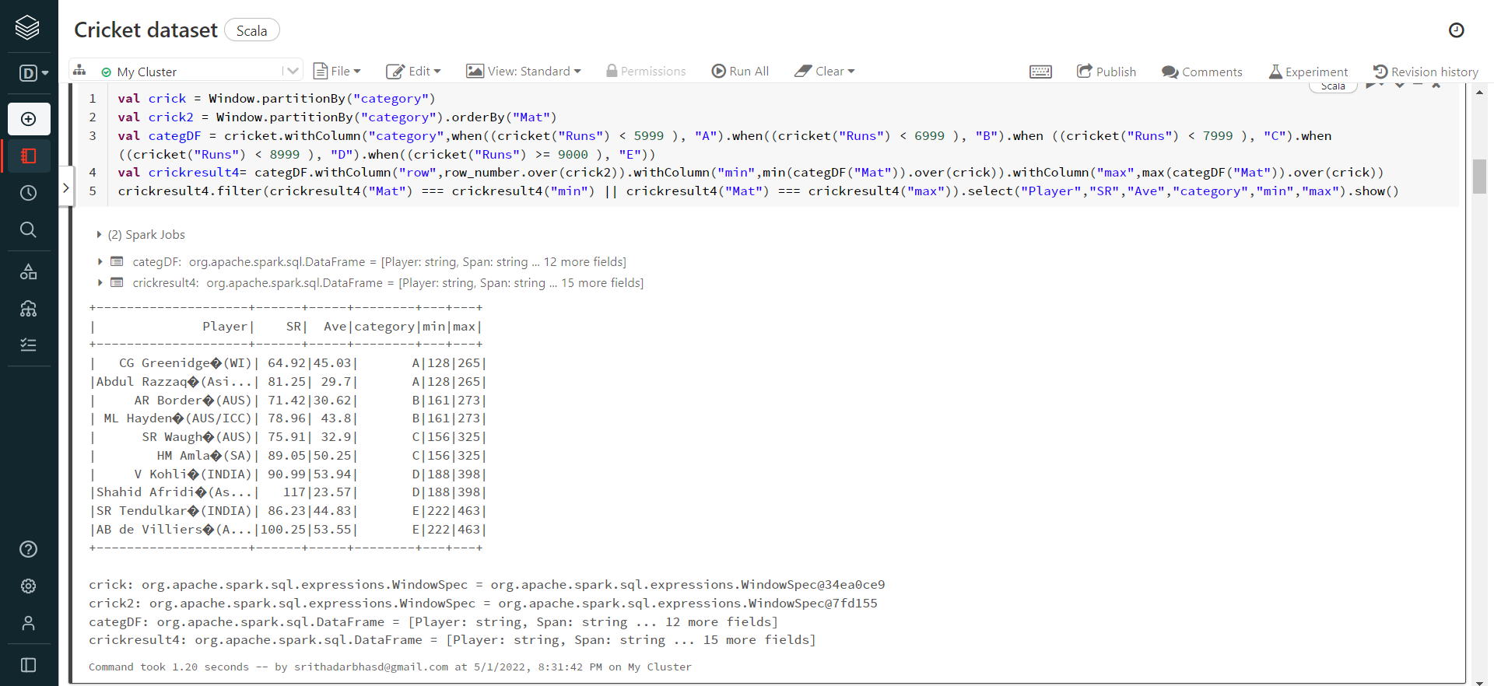

**Question 5:** Create any two visualizations on given data and explain importance? You can use any column or parse the data in column to make your visualization. Example: count of players in each category in the above query.

Solution:

*//question5*

*import sqlContext.implicits._*

*import org.apache.spark.sql._*

*import org.apache.spark.sql.functions._*

*import org.apache.spark.sql.expressions.Window*

*import org.apache.spark.sql.RelationalGroupedDataset*

*val cricketDF= sqlContext.read*

*.format("com.databricks.spark.csv")*

*.option("header","true")*

*.option("inferSchema","true")*

*.load ("dbfs:/FileStore/tables/Cricket.csv")*

*val cricket_category = cricketDF.withColumn("Category",when((cricketDF("Runs") < 5999 ), "1").when((cricketDF("Runs") < 6999 ), "2").when((cricketDF("Runs") < 7999 ), "3").when ((cricketDF("Runs") < 8999 ), "4").when((cricketDF("Runs") >= 9000 ), "5"))*

*cricket_category.show()*

*val MinMaxMatches = cricket_category.groupBy("Category").agg(min("Mat").as("MinimumMatch"), max("Mat").as("MaximumMatch")).withColumnRenamed("Category":String, "Category2": String)*

*MinMaxMatches.show()*

*val cricket_result = cricket_category.join(MinMaxMatches,cricket_category("Category") === MinMaxMatches("Category2"),"inner").orderBy("Runs")*

*cricket_result.select("Player","SR","Ave","Category","MinimumMatch","MaximumMatch","HS").show()*

*cricket_result.printSchema()*

*display(cricket_result.select("MinimumMatch","MaximumMatch","HS","Ave","Player","Category"))*

*cricketDF.createOrReplaceTempView("cricket")*

*val cricket_1 = spark.sql("select * from cricket")*

*val cricket_2 = cricket_1.withColumn("HS",regexp_replace($"HS","\\*",""))*

*val cricket_3 = cricket_2.withColumn("HS",$"HS".cast("int")).orderBy("Mat")*

*val cricket_4 = cricket_3.withColumn("MatRange",*

*when((cricket_3("Mat") >= 100 && cricket_3("Mat") < 200), "100-199")*

*.when((cricket_3("Mat") >= 200 && cricket_3("Mat") < 300), "200-299")*

*.when((cricket_3("Mat") >= 300 && cricket_3("Mat") < 400), "300-399")*

*.when((cricket_3("Mat") >= 400 && cricket_3("Mat") < 500), "400-499"))*

*cricket_4.printSchema()*

*display(cricket_4.select("MatRange","Ave","100","50","0"))*

*display(cricket_4.select("MatRange","HS"))*

Bonus:

import org.apache.spark.ml.evaluation.RegressionEvaluator

import org.apache.spark.ml.regression.LinearRegression

import org.apache.spark.ml.tuning.{ParamGridBuilder, TrainValidationSplit}

import org.apache.log4j._

import org.apache.spark.ml.feature.VectorAssembler

import org.apache.spark.mllib.linalg.Vectors

*val cricketdf = cricket_4.select("Runs","BF","SR")*

*cricketdf.show()*

*val cricketdf1 =cricketdf.select(cricketdf("Runs").as("label"),$"SR",$"BF")*

*cricketdf1.show()*

*val assembler = new VectorAssembler().setInputCols(Array("SR","BF")).setOutputCol("features")*

*val cricketdf2 = assembler.transform(cricketdf1).select($"label",$"features")*

*cricketdf2.show()*

*val lr = new LinearRegression()*

*val lrModel = lr.fit(cricketdf2)*

*println(s"Coefficients:${lrModel.coefficients} Intercept: ${lrModel.intercept}")*

*val trainingSummary = lrModel.summary*

*println(s"numIterations: ${trainingSummary.totalIterations}")*

*println(s"objectiveHistory:${trainingSummary.objectiveHistory.toList}")*

*trainingSummary.residuals.show()*

*println(s"RMSE: ${trainingSummary.rootMeanSquaredError}")*

*println(s"MSE: ${trainingSummary.meanSquaredError}")*

*println(s"r2:${trainingSummary.r2}")*

Used the data from the fourth question to display Minimum and Maximum Matches, HS, Average, Player name and Category. Used the same data to find players with match numbers between 100-199,200-299, 300-399 and 400-499 and used the data to display the visualizations. Used Linear Regression model to predict the runs using Strike Rate and Balls Faced.

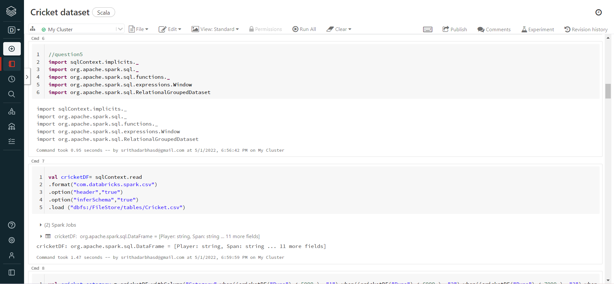

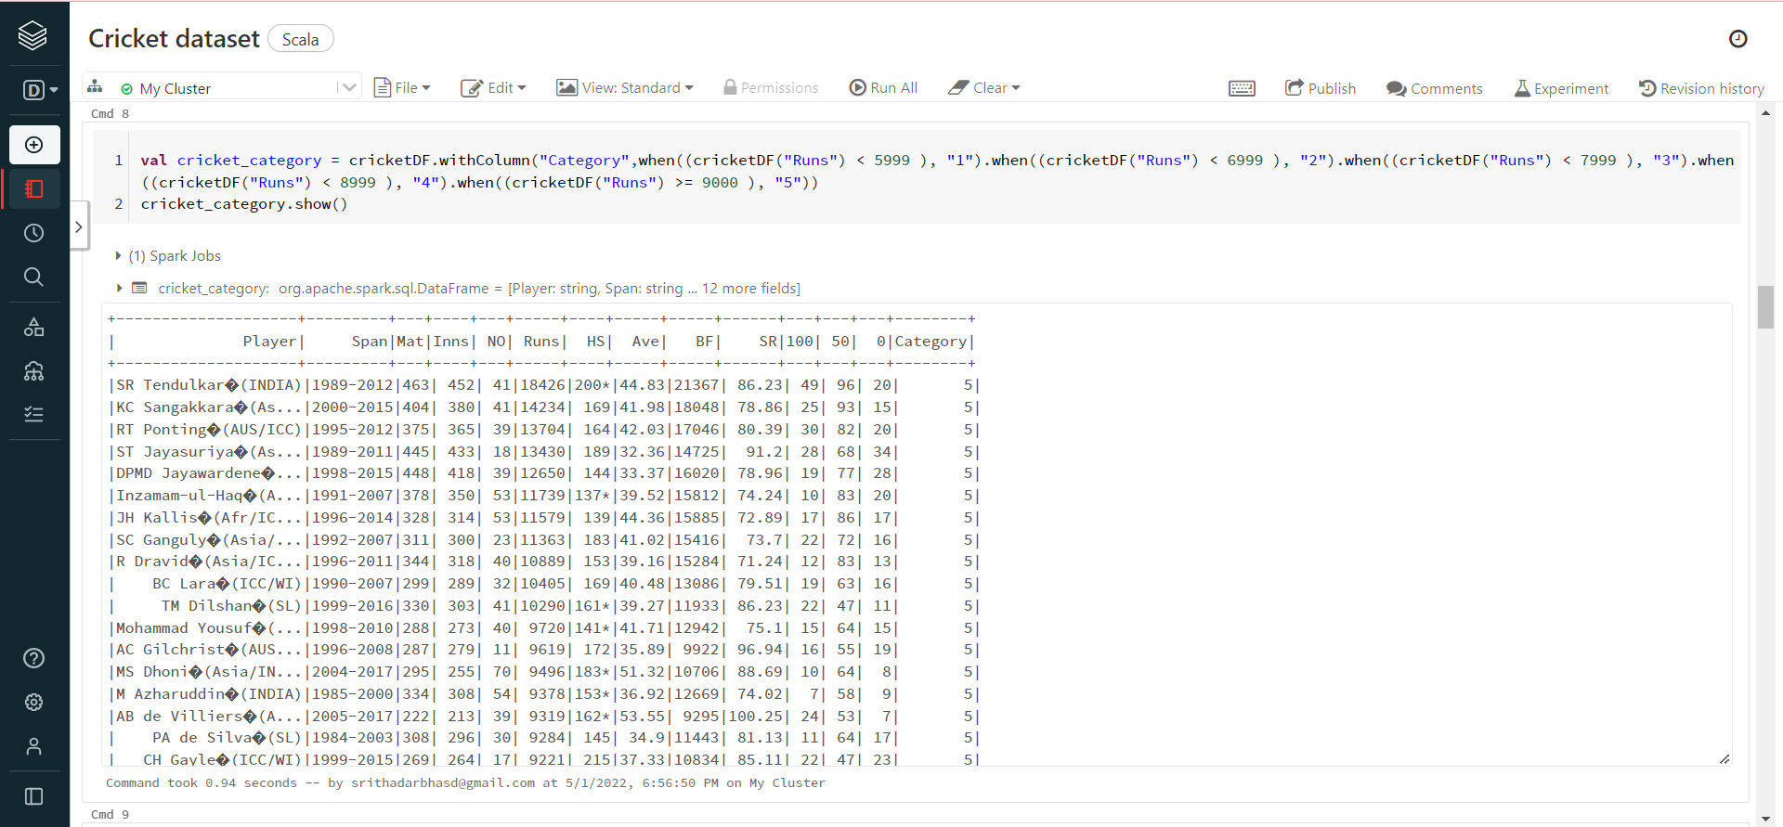

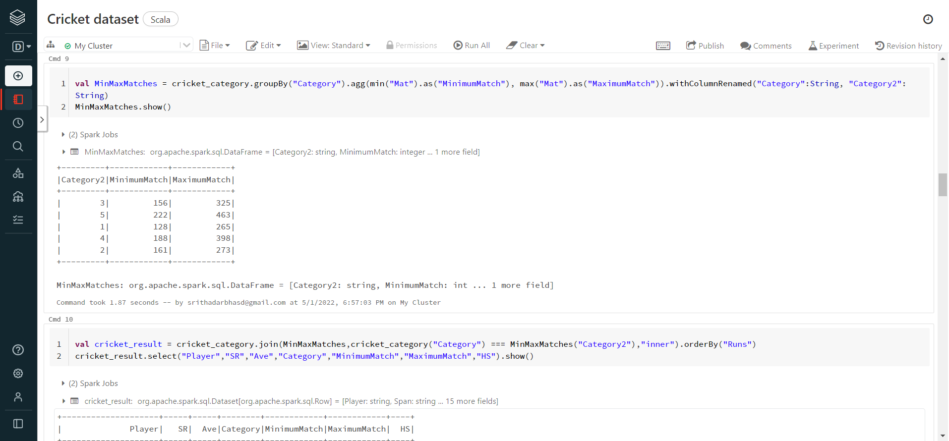

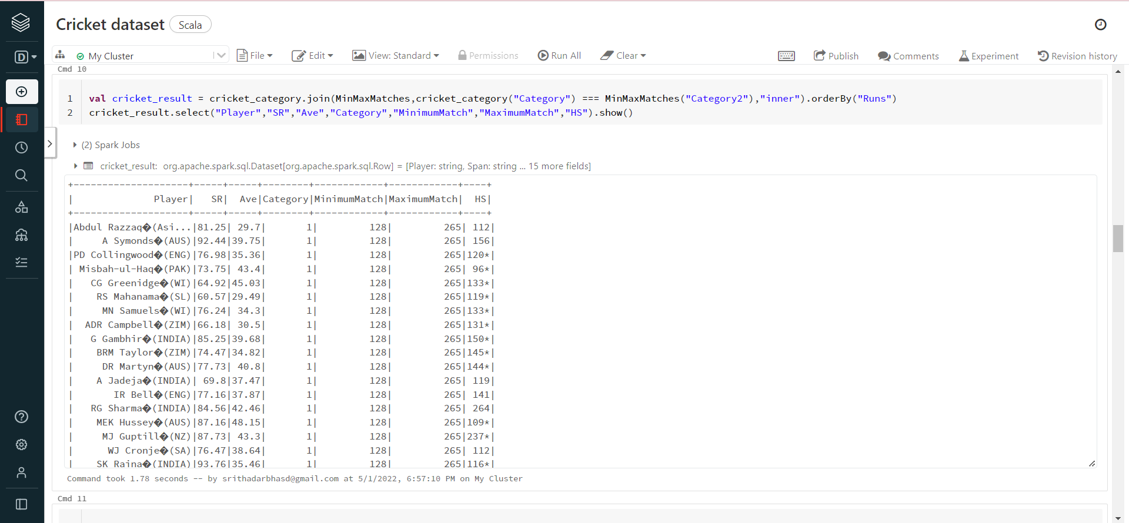

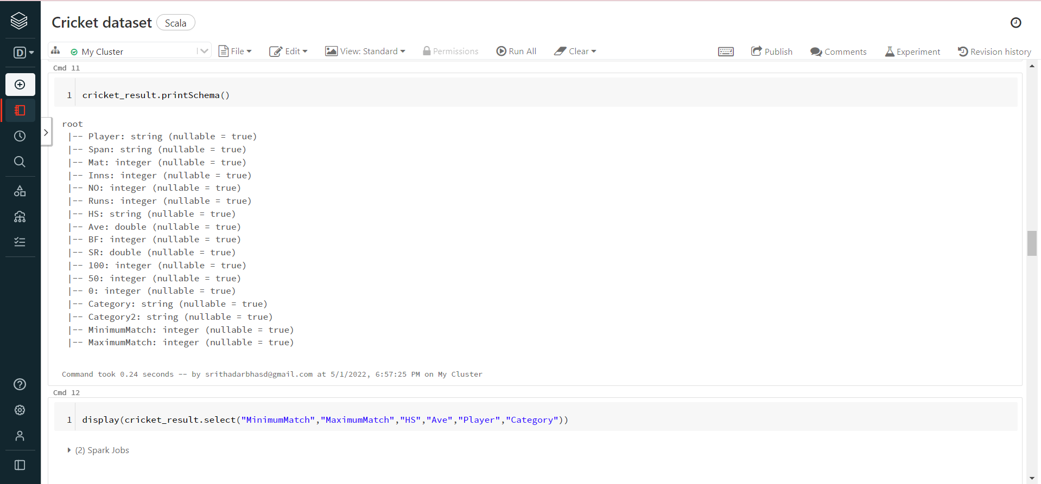

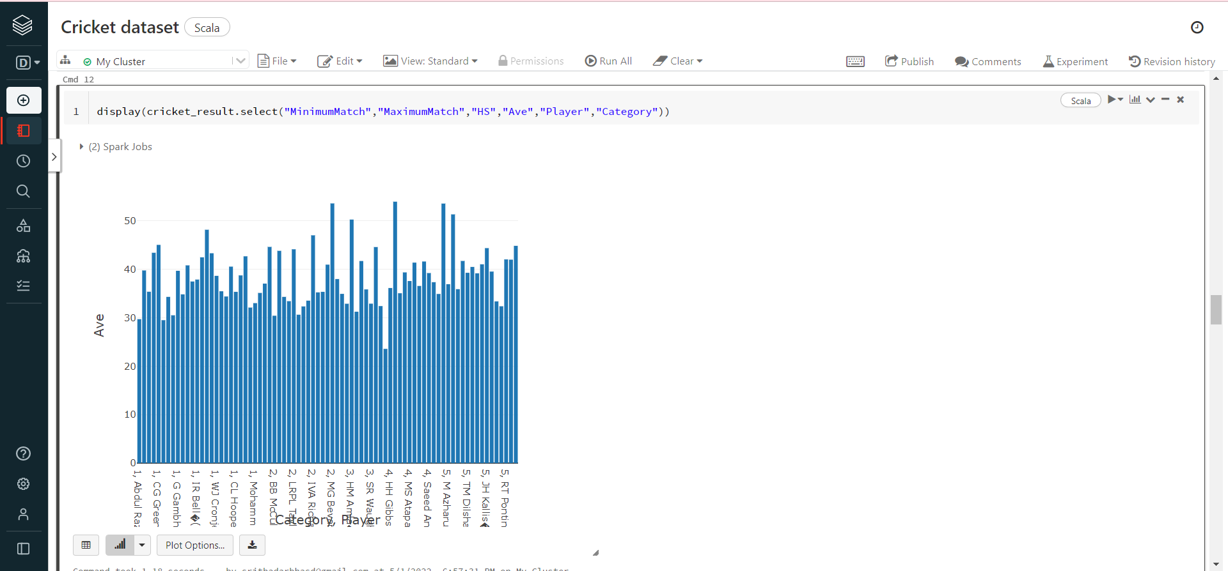

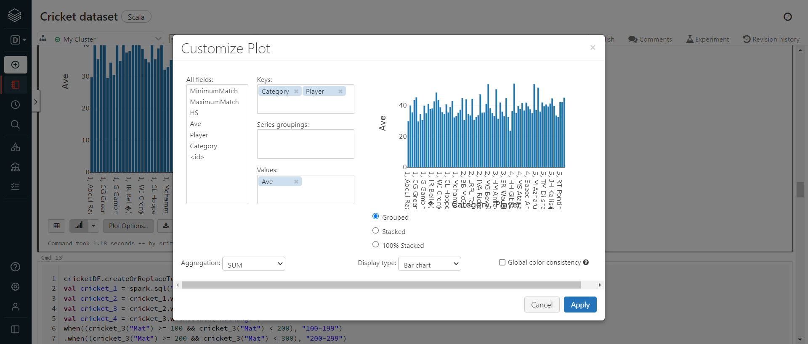

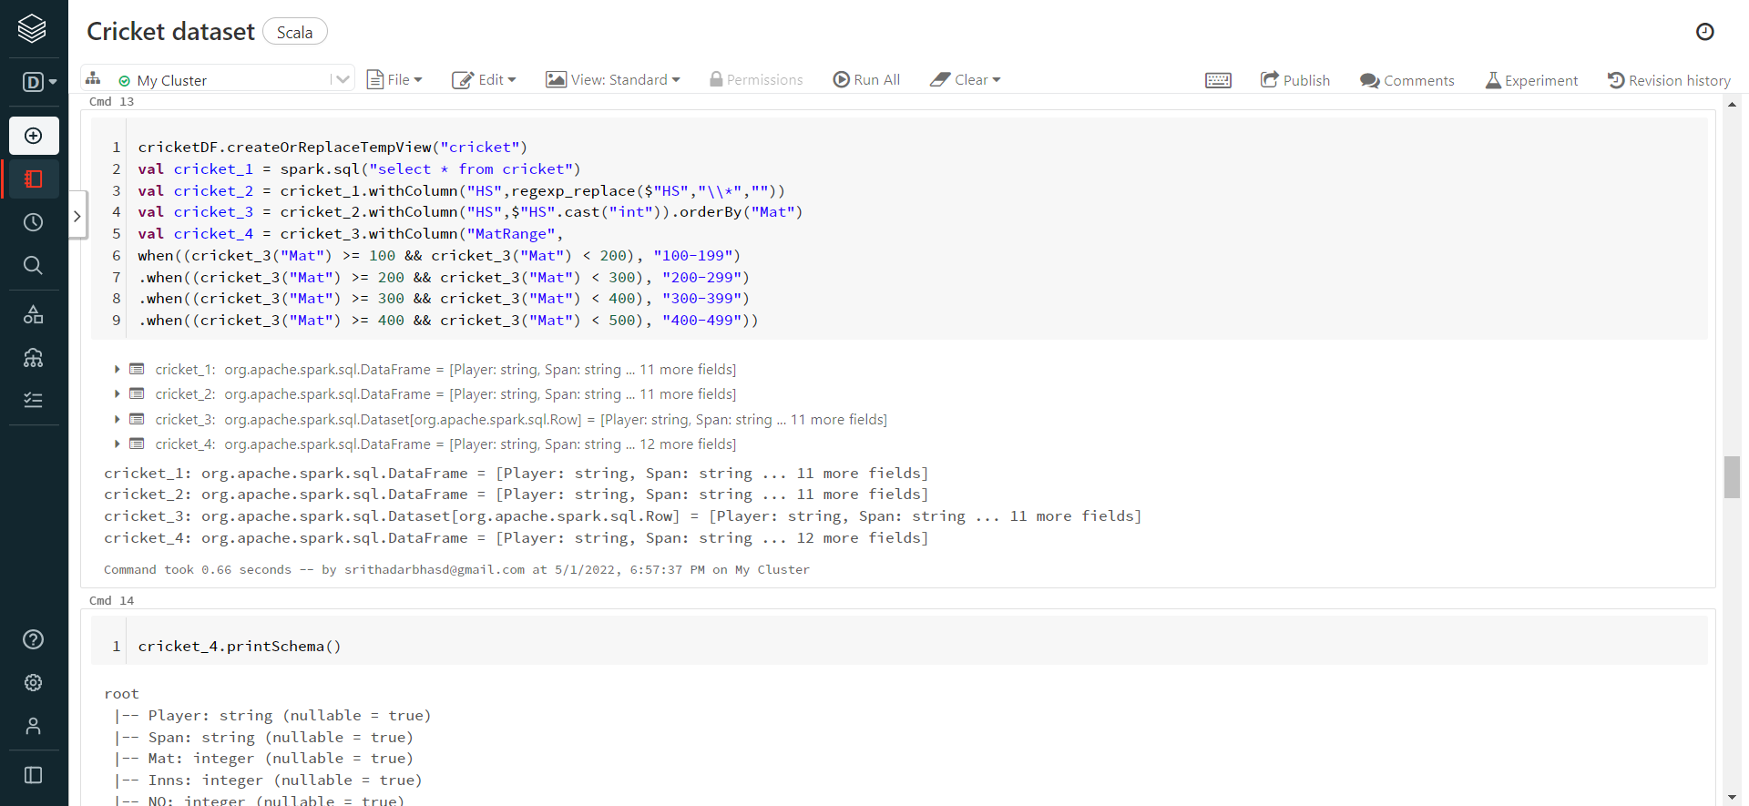

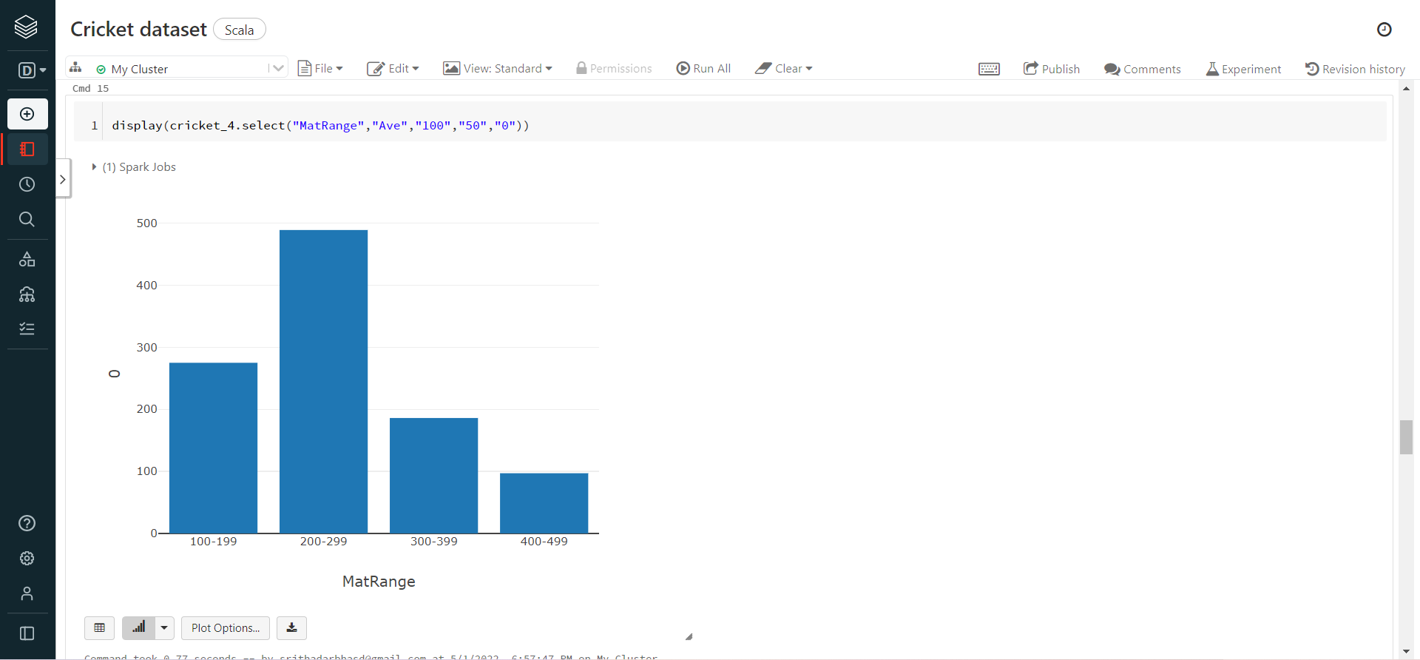

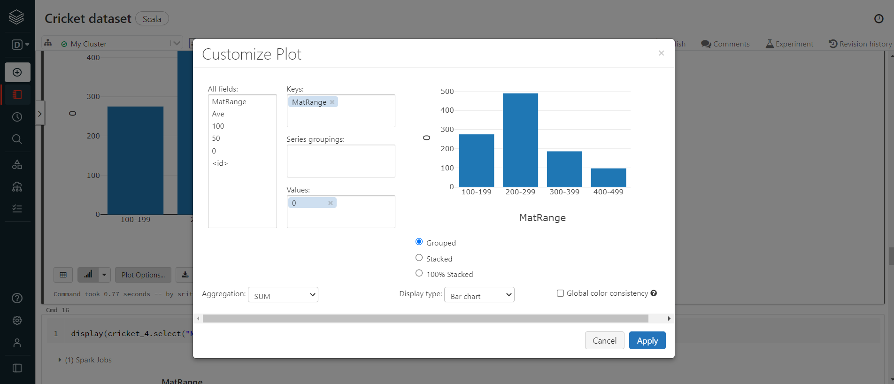

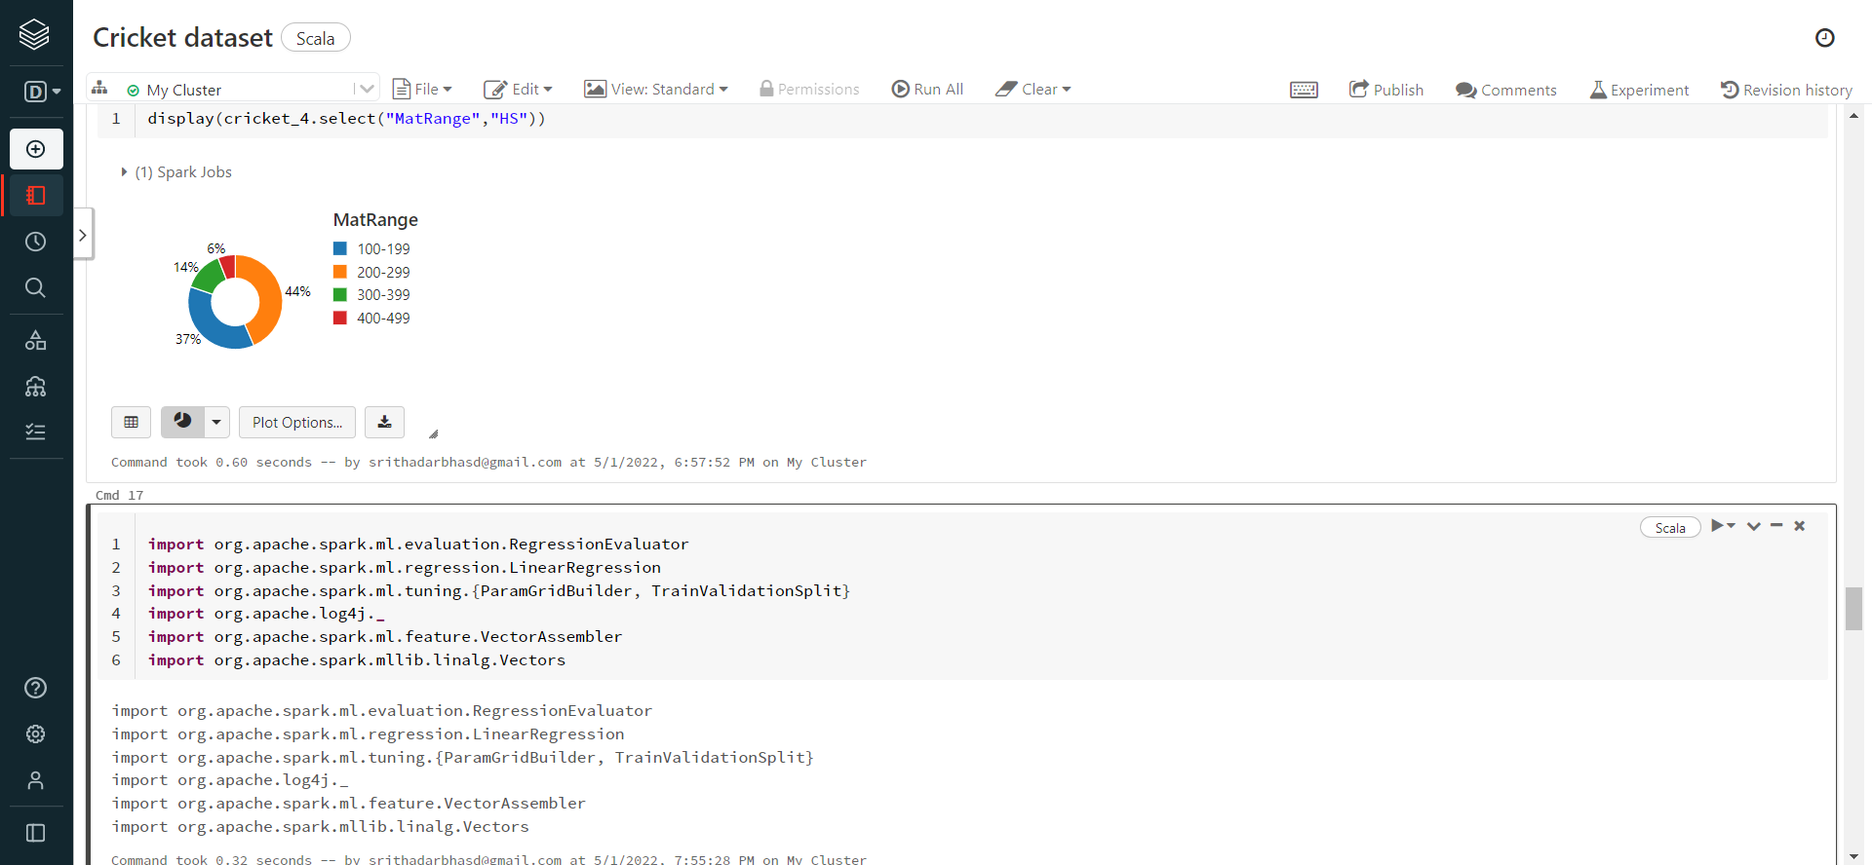

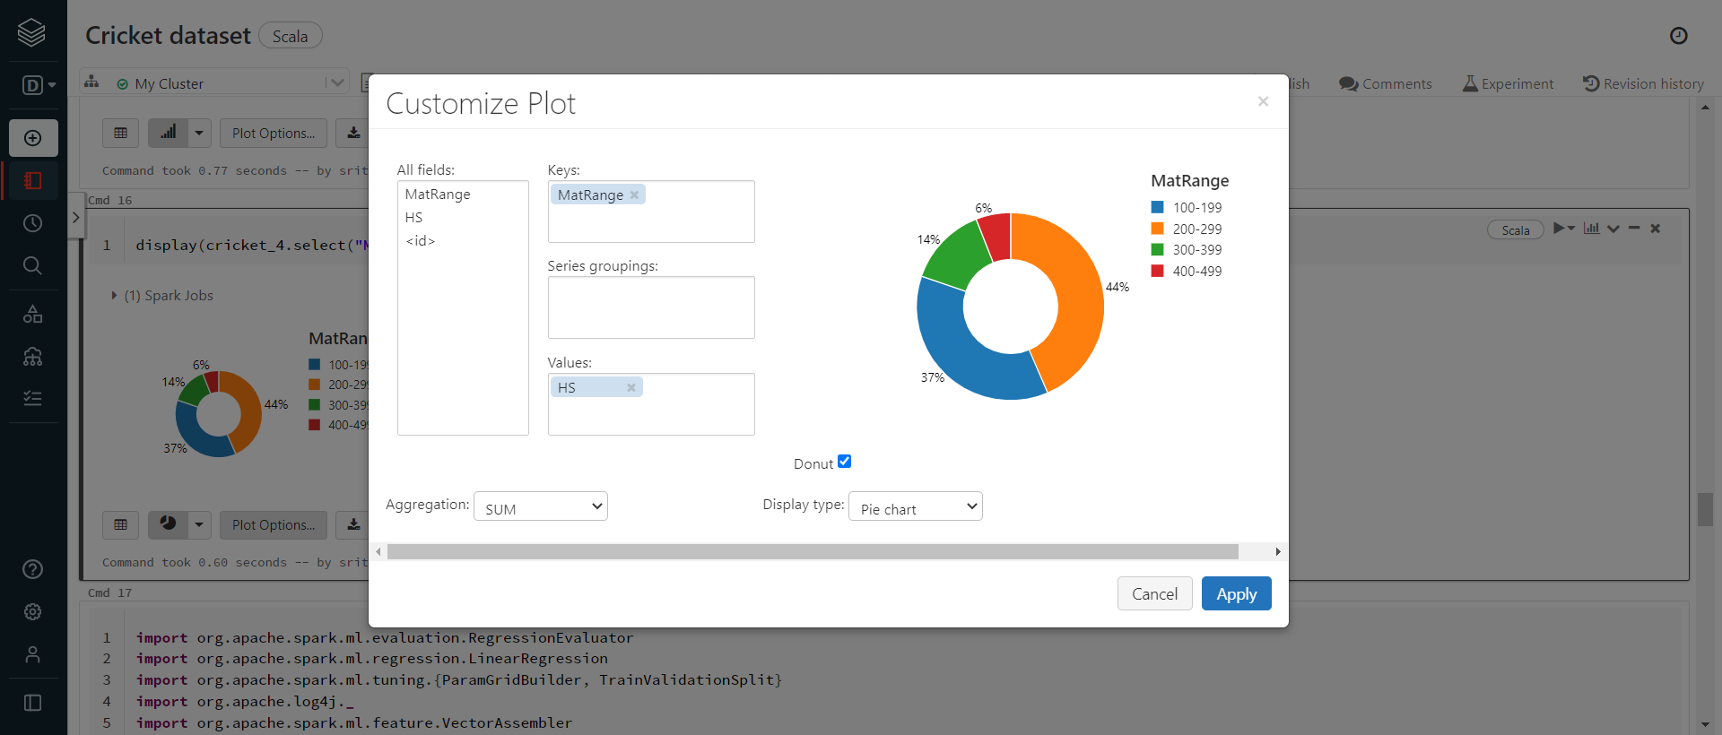

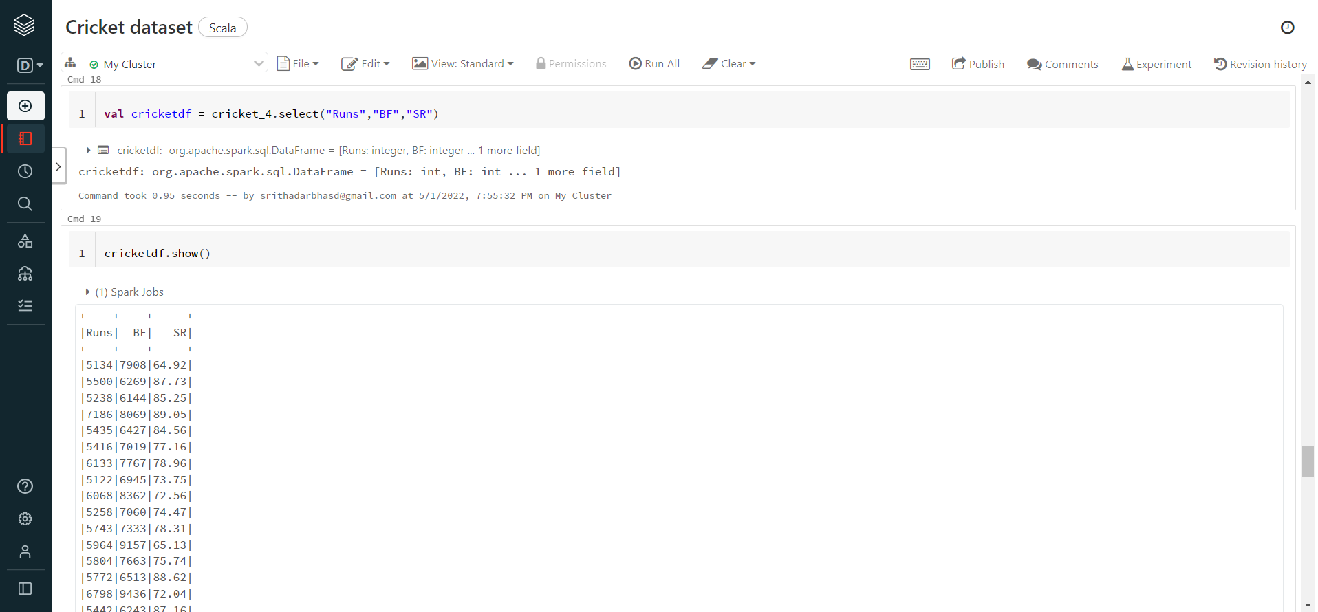

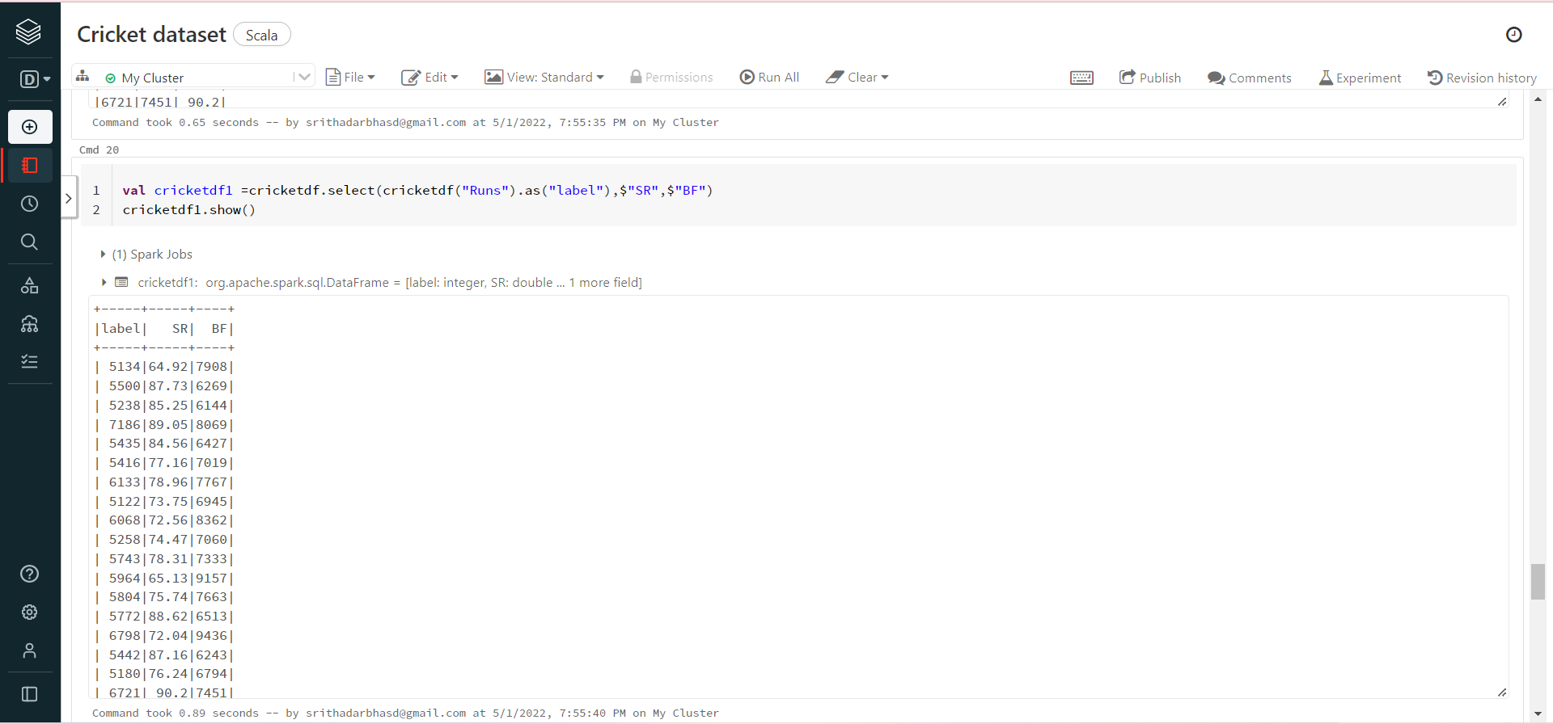

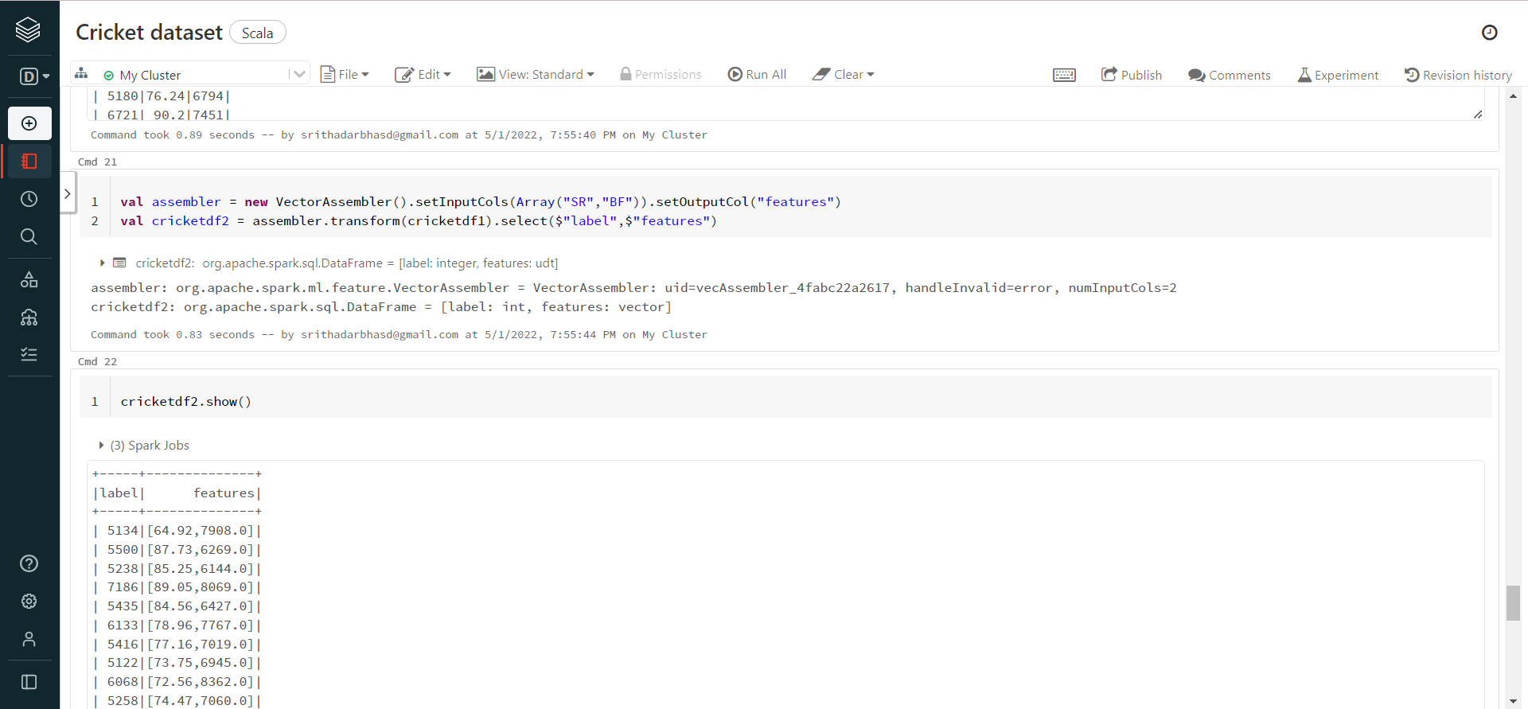

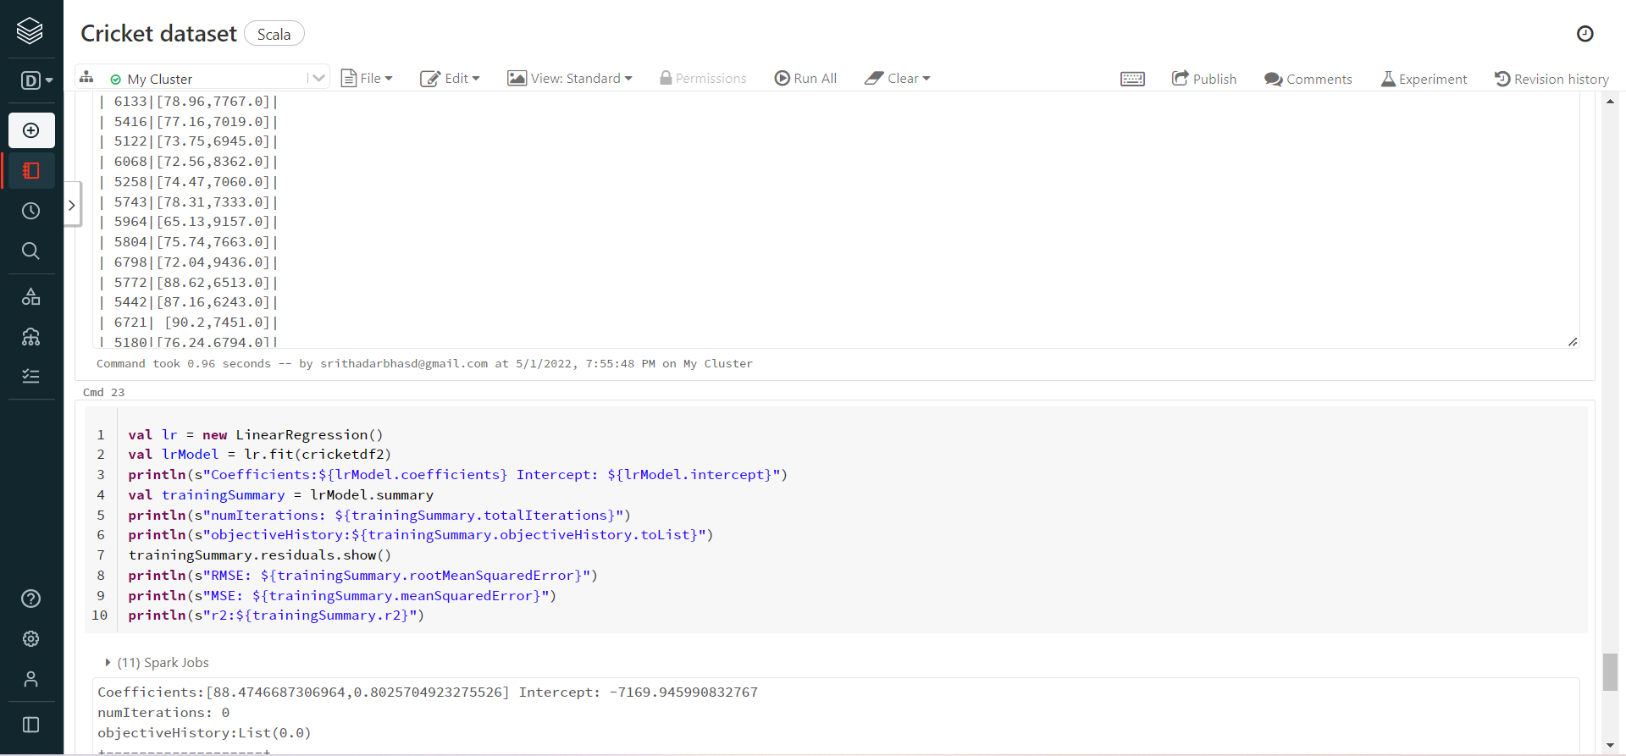

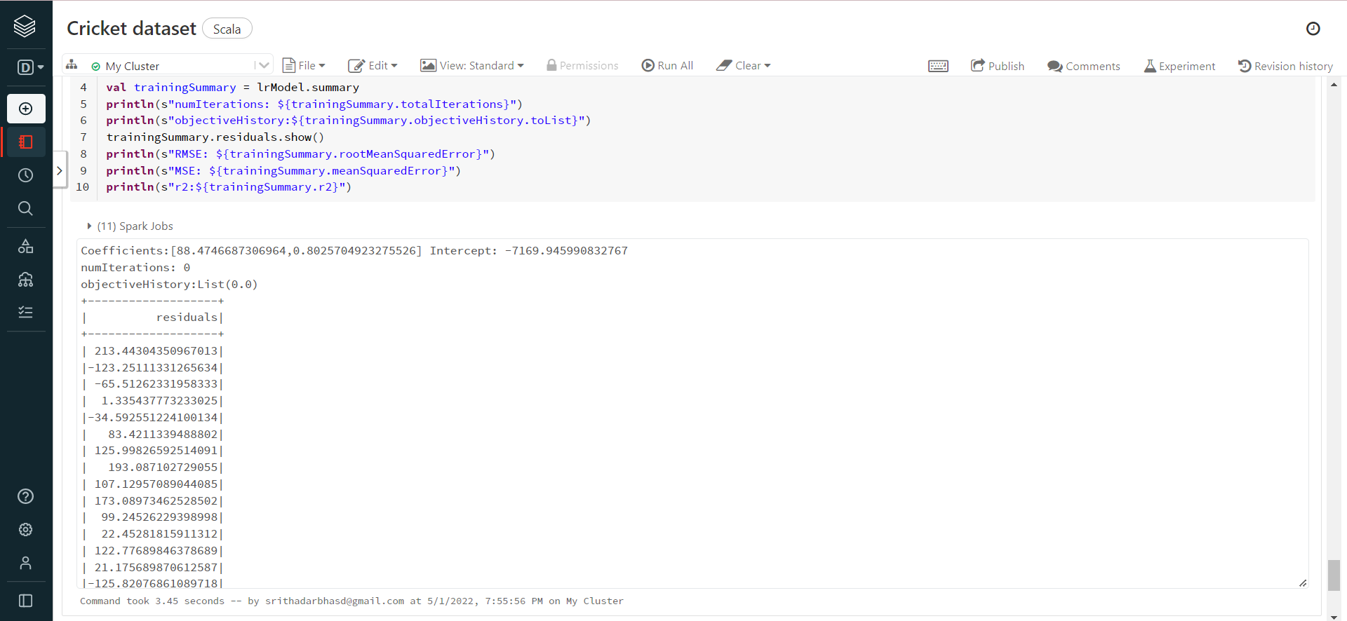

<https://databricks-prod-cloudfront.cloud.databricks.com/public/4027ec902e239c93eaaa8714f173bcfc/3992816840459507/2042336585088475/7611368440882824/latest.html>

**Sales Analysis**

**By Sritha Darbha**

Loading Hive

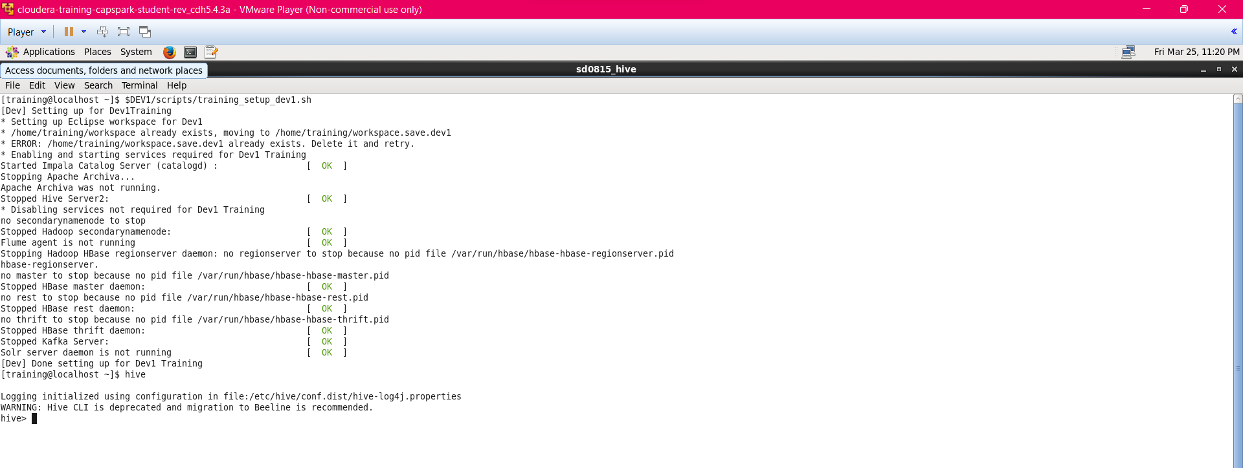

**Question:** James want to invest in Ford company stock and needs help in analysing data.

Data is provided in “txt” format. Load the data into a Hive table

creating a database and loading ford data into hive, validating the data in the table.

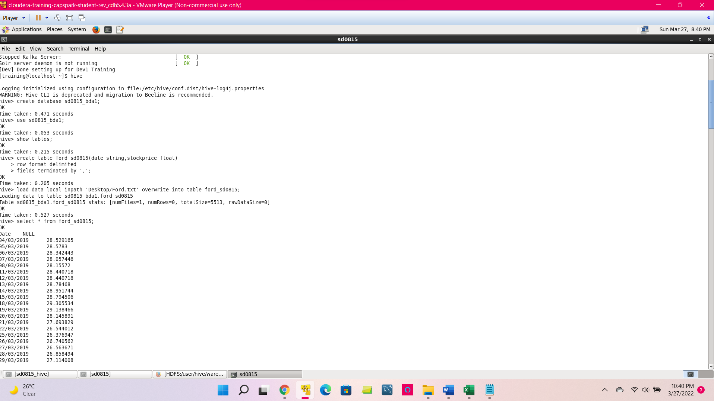

* James wants to compare pricing across months by viewing percentage change across months. Write the SQL statement that allows James to do that.

To compare pricing across months by viewing percentage change across months:

Changing datatype to date

grouping by year,month

calculating average previous price

calculating percentage change

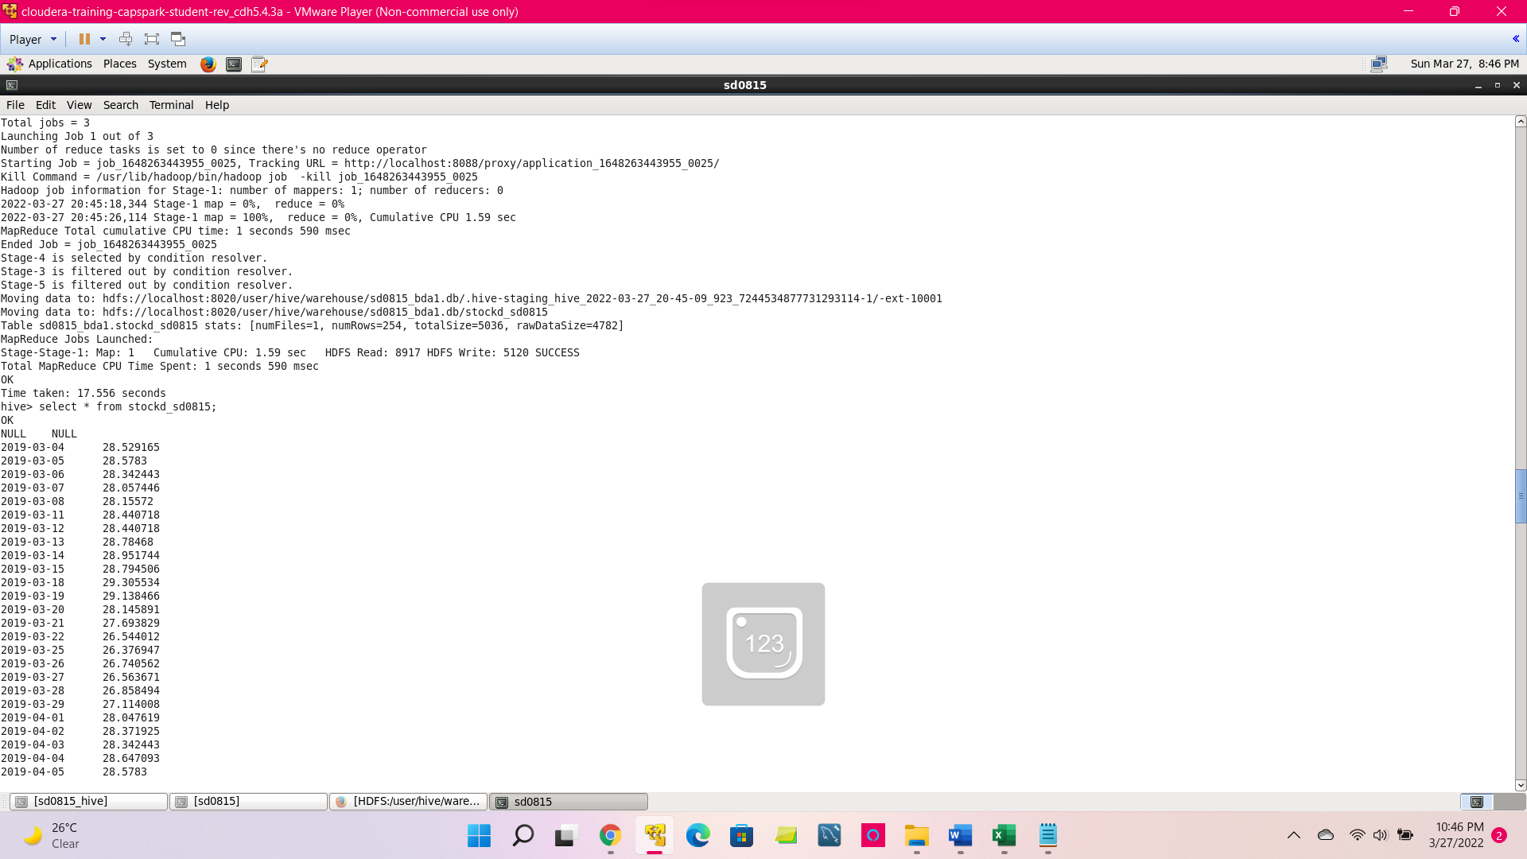

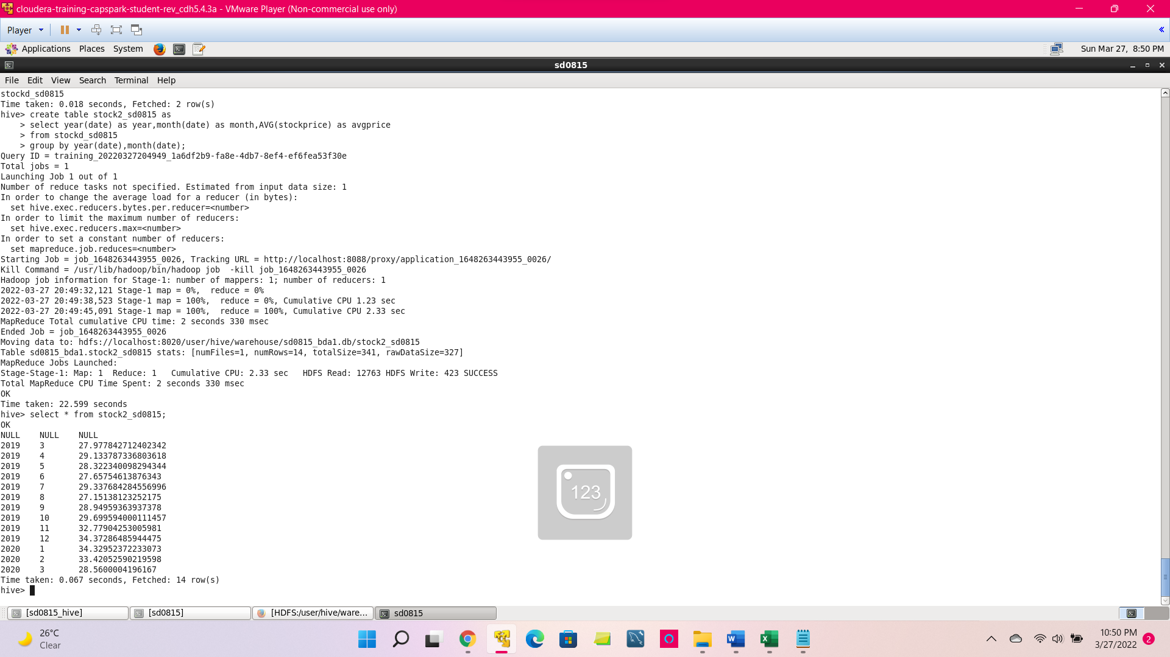

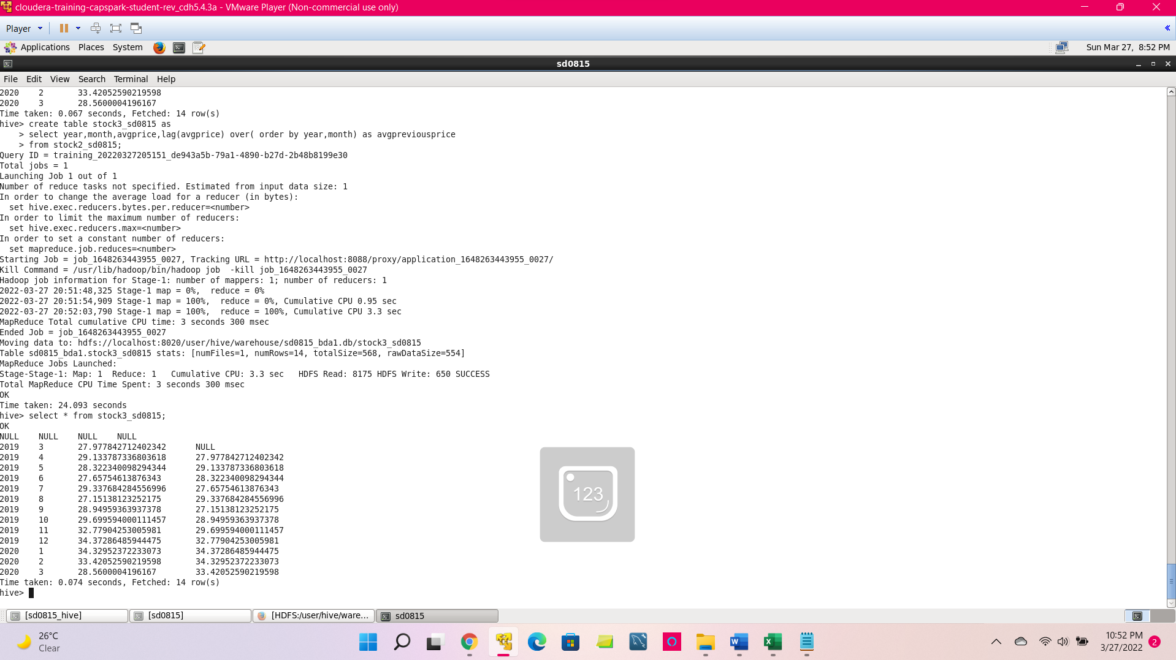

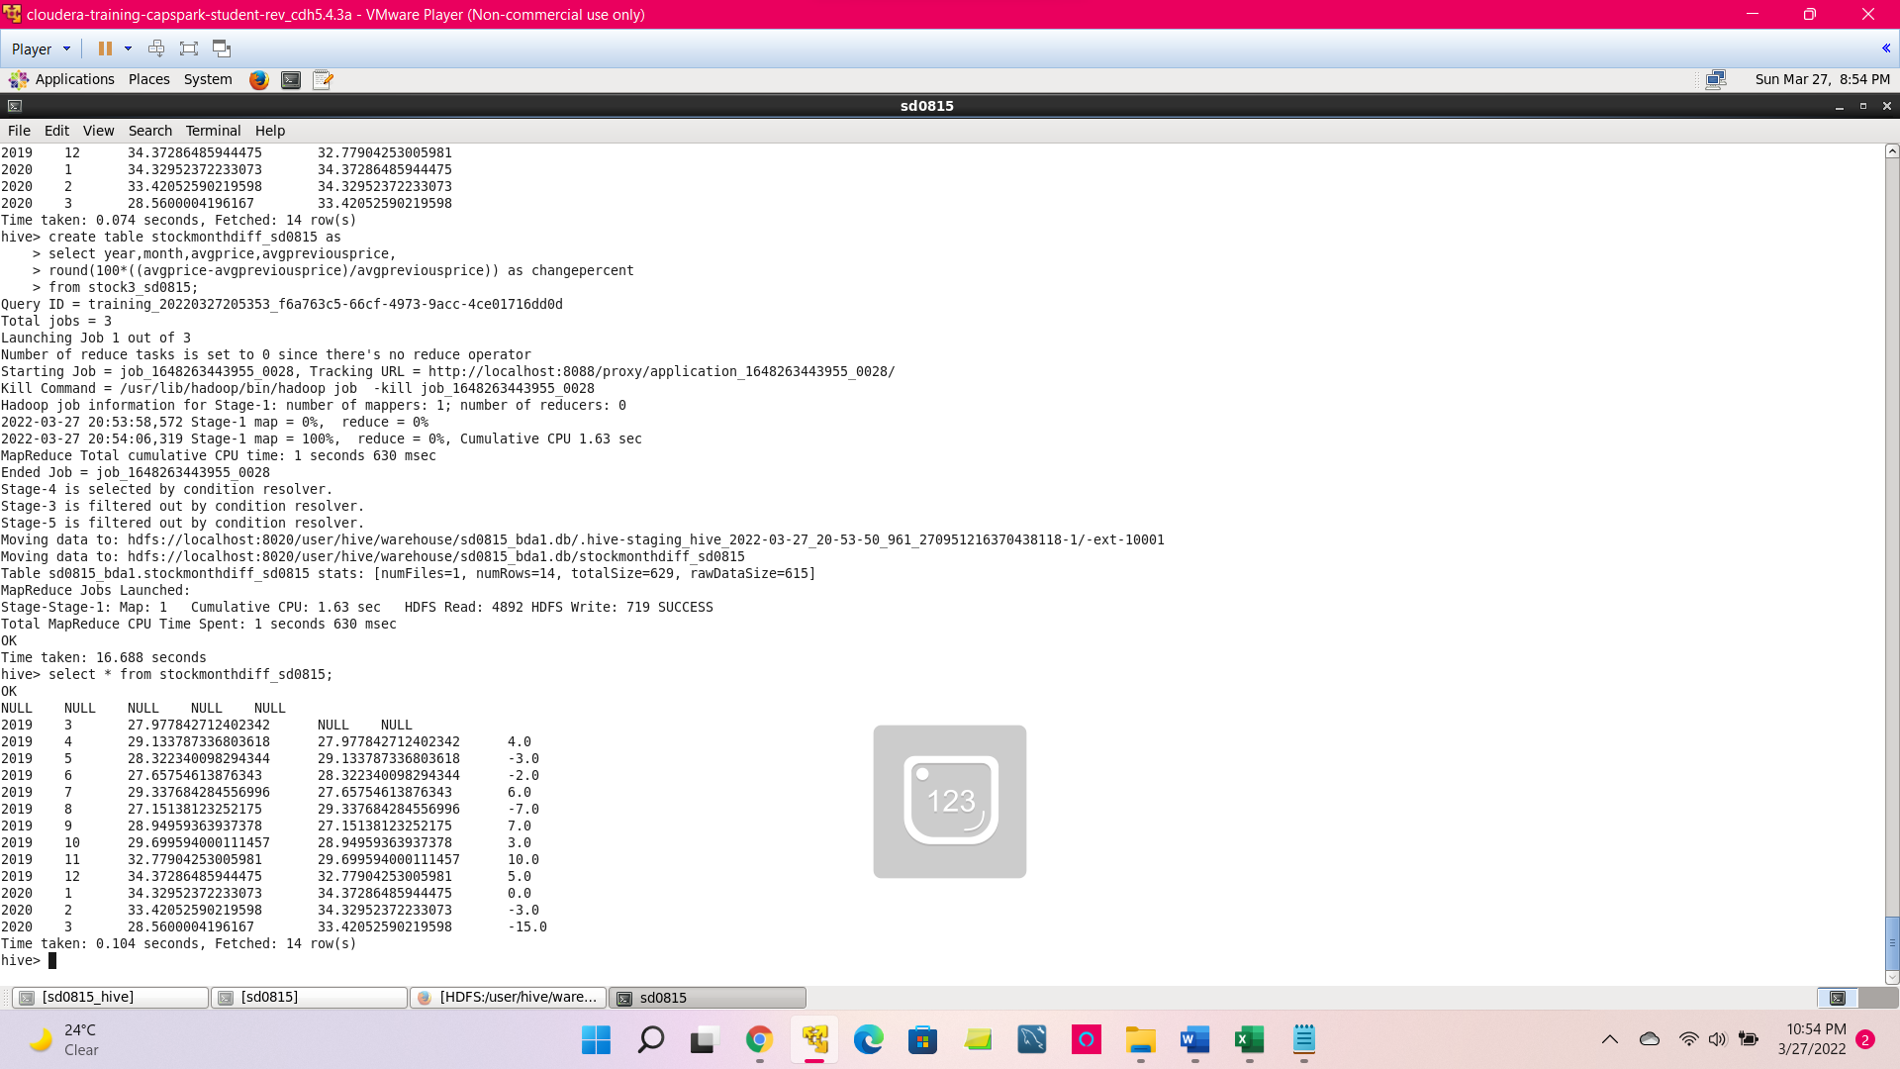

* James want to hold the stock for at least four consecutive months. Which period is most suitable for maximizing the profit?

Using stock2_sd0815 from above and altering the table data to string

Then using lead function to make the loop for sum of four consecutive months

And finding the max value for profits.

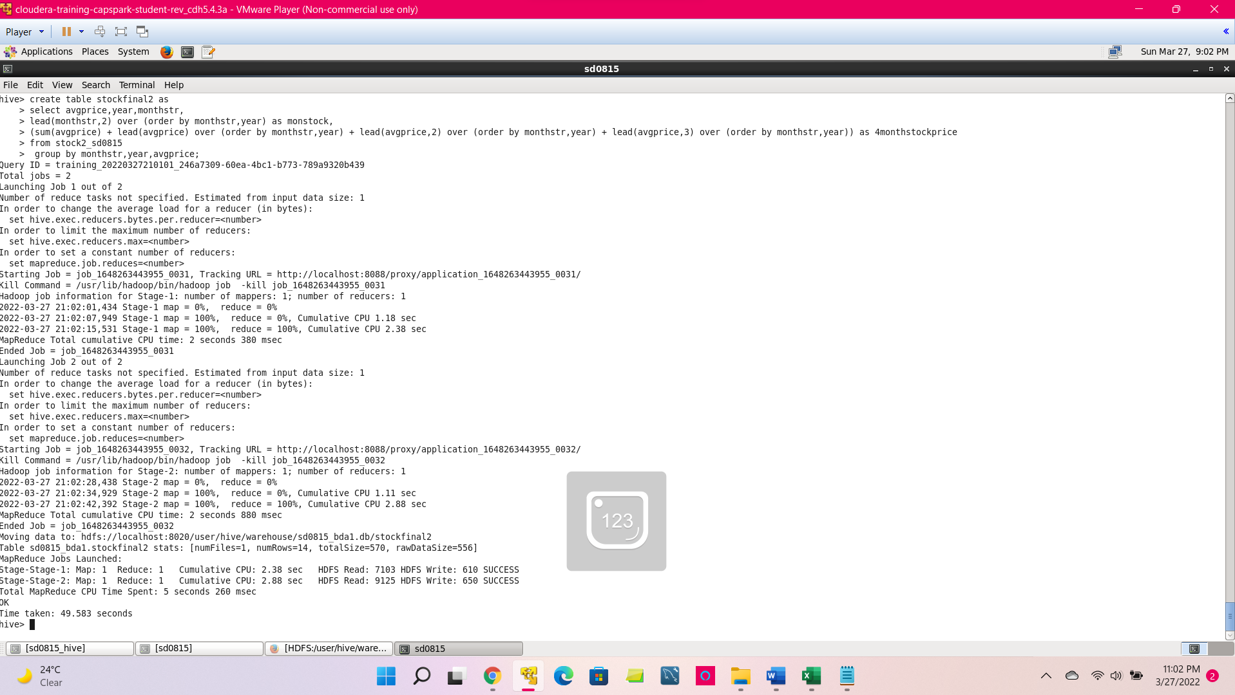

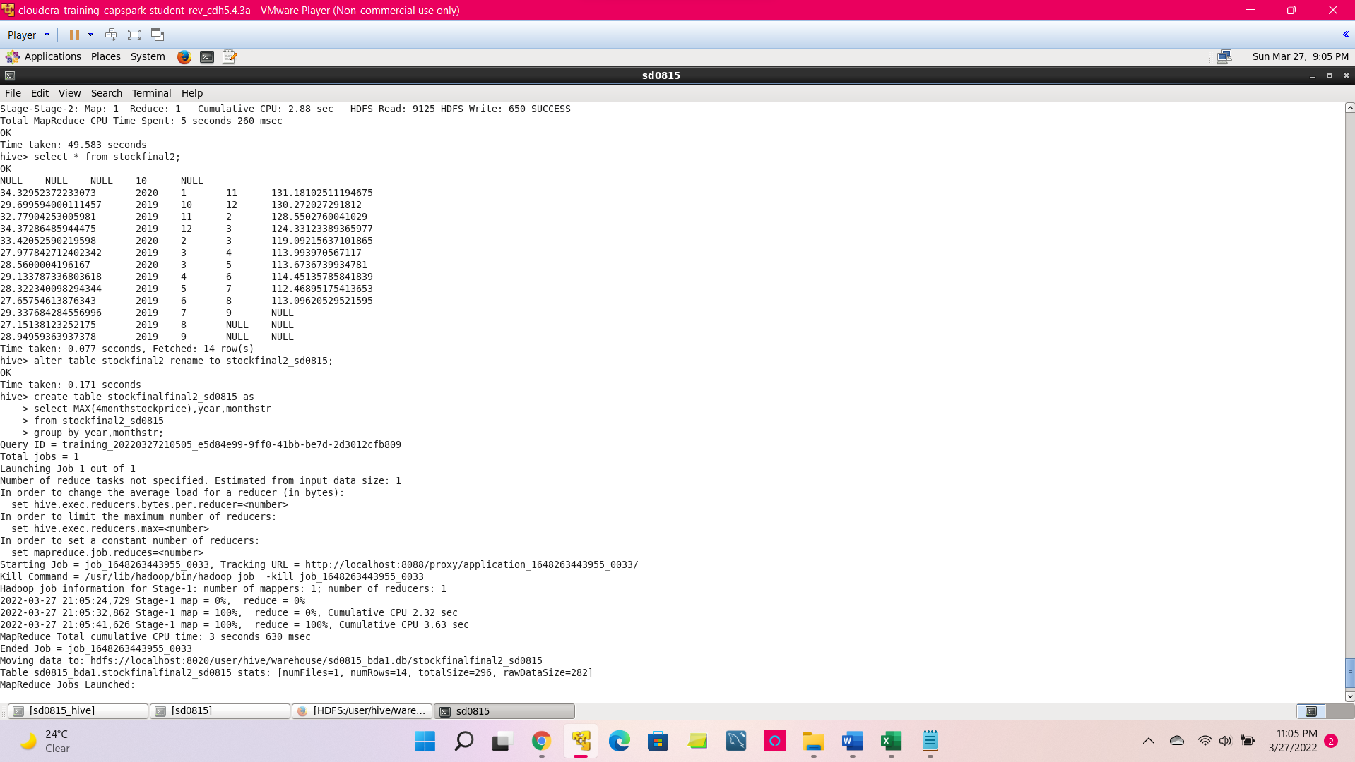

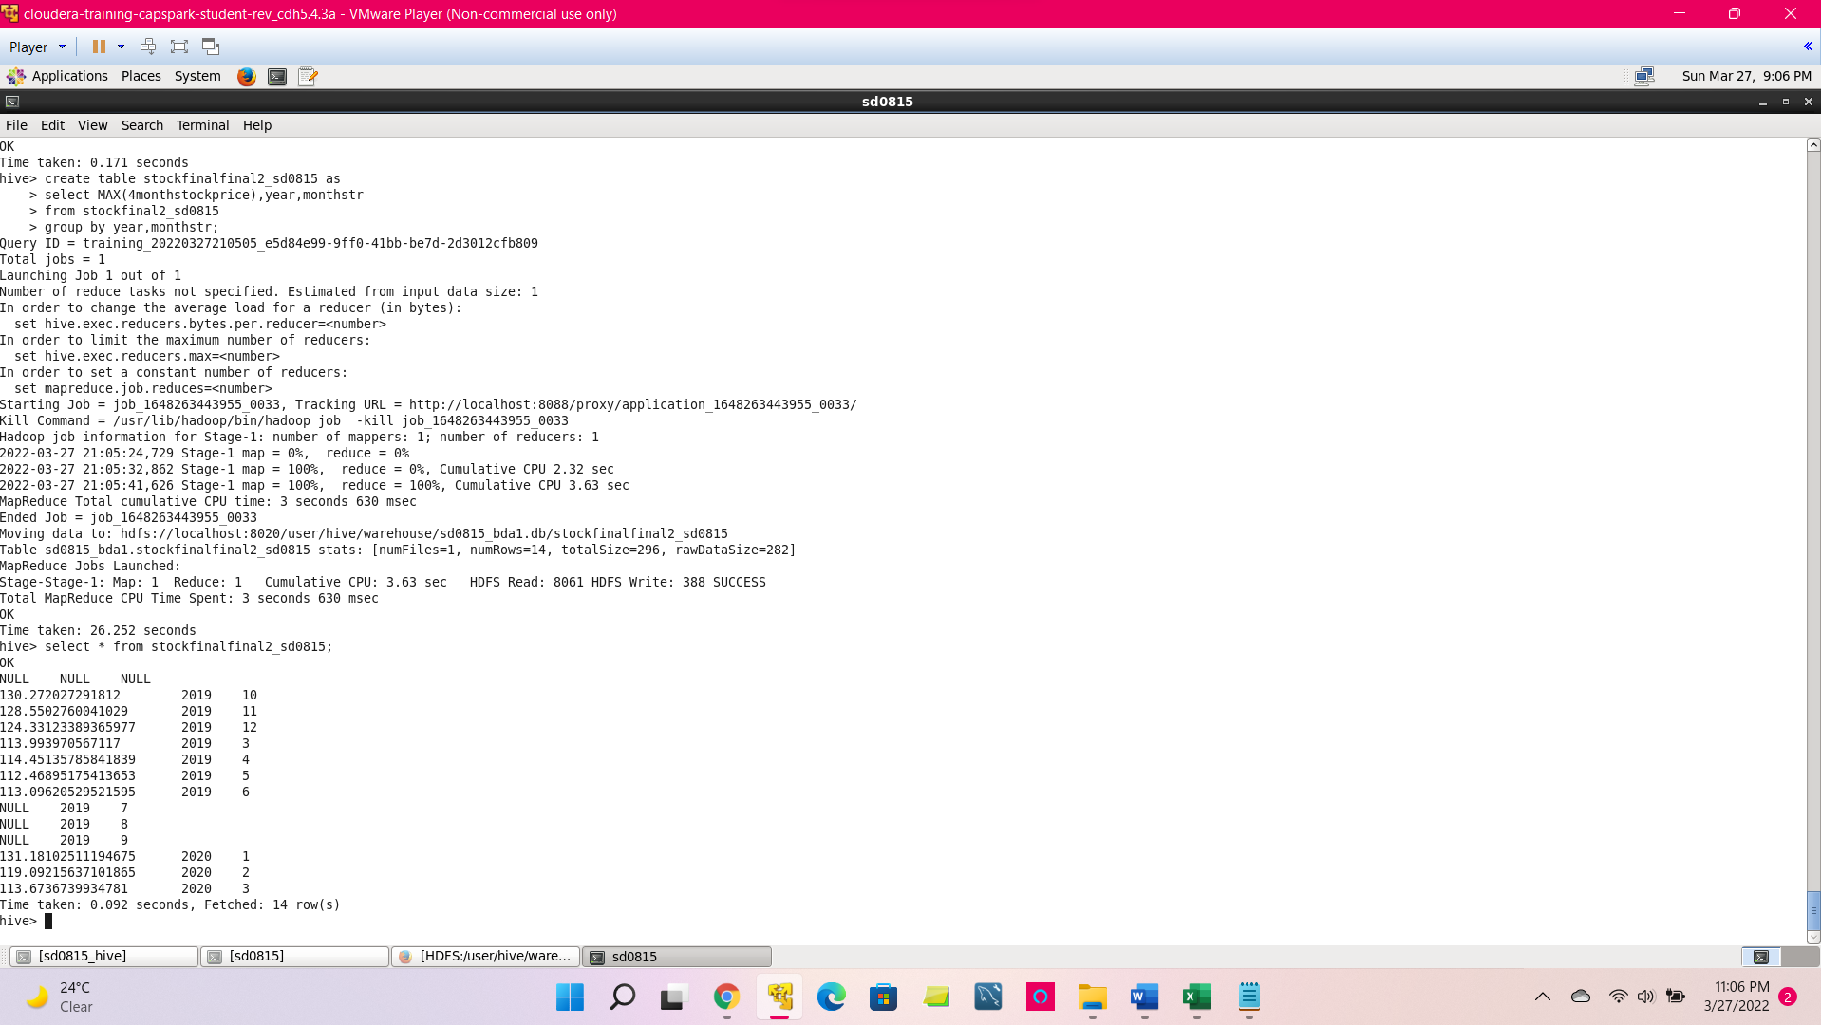

**Question:** Michael has an online business that sells electronic items.

* Process data using your VM and store in Hive table(s)

Loading and validating the data in hive

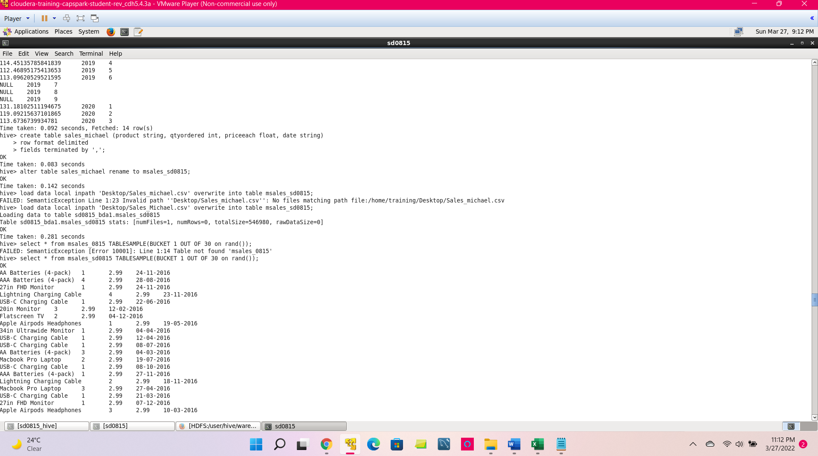

* Michael wants to view a list of top three items sold in every quarter. Write a SQL query that allows Michael to see the results.

to divide the dates into quarters and ranking the products based on qty sold in each quarter

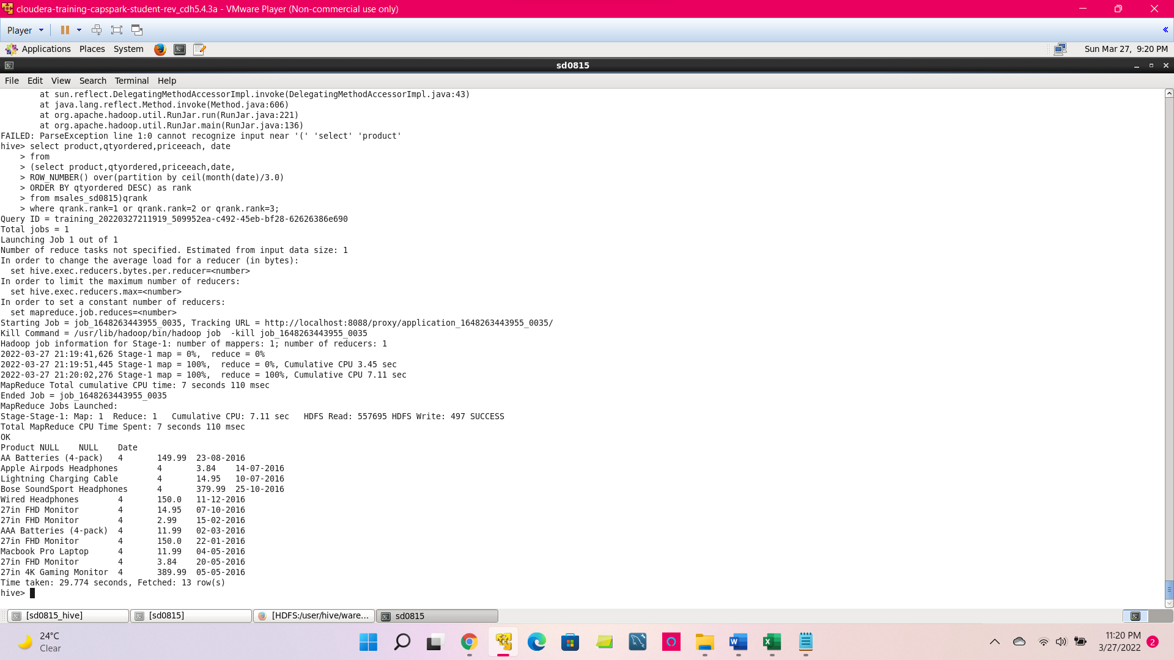

* Help Michael segregate products into three categories: *expensive*, *mid-range* and *cheap*.

to segregate the products as cheap,midrange and expensive using when then loop conditions

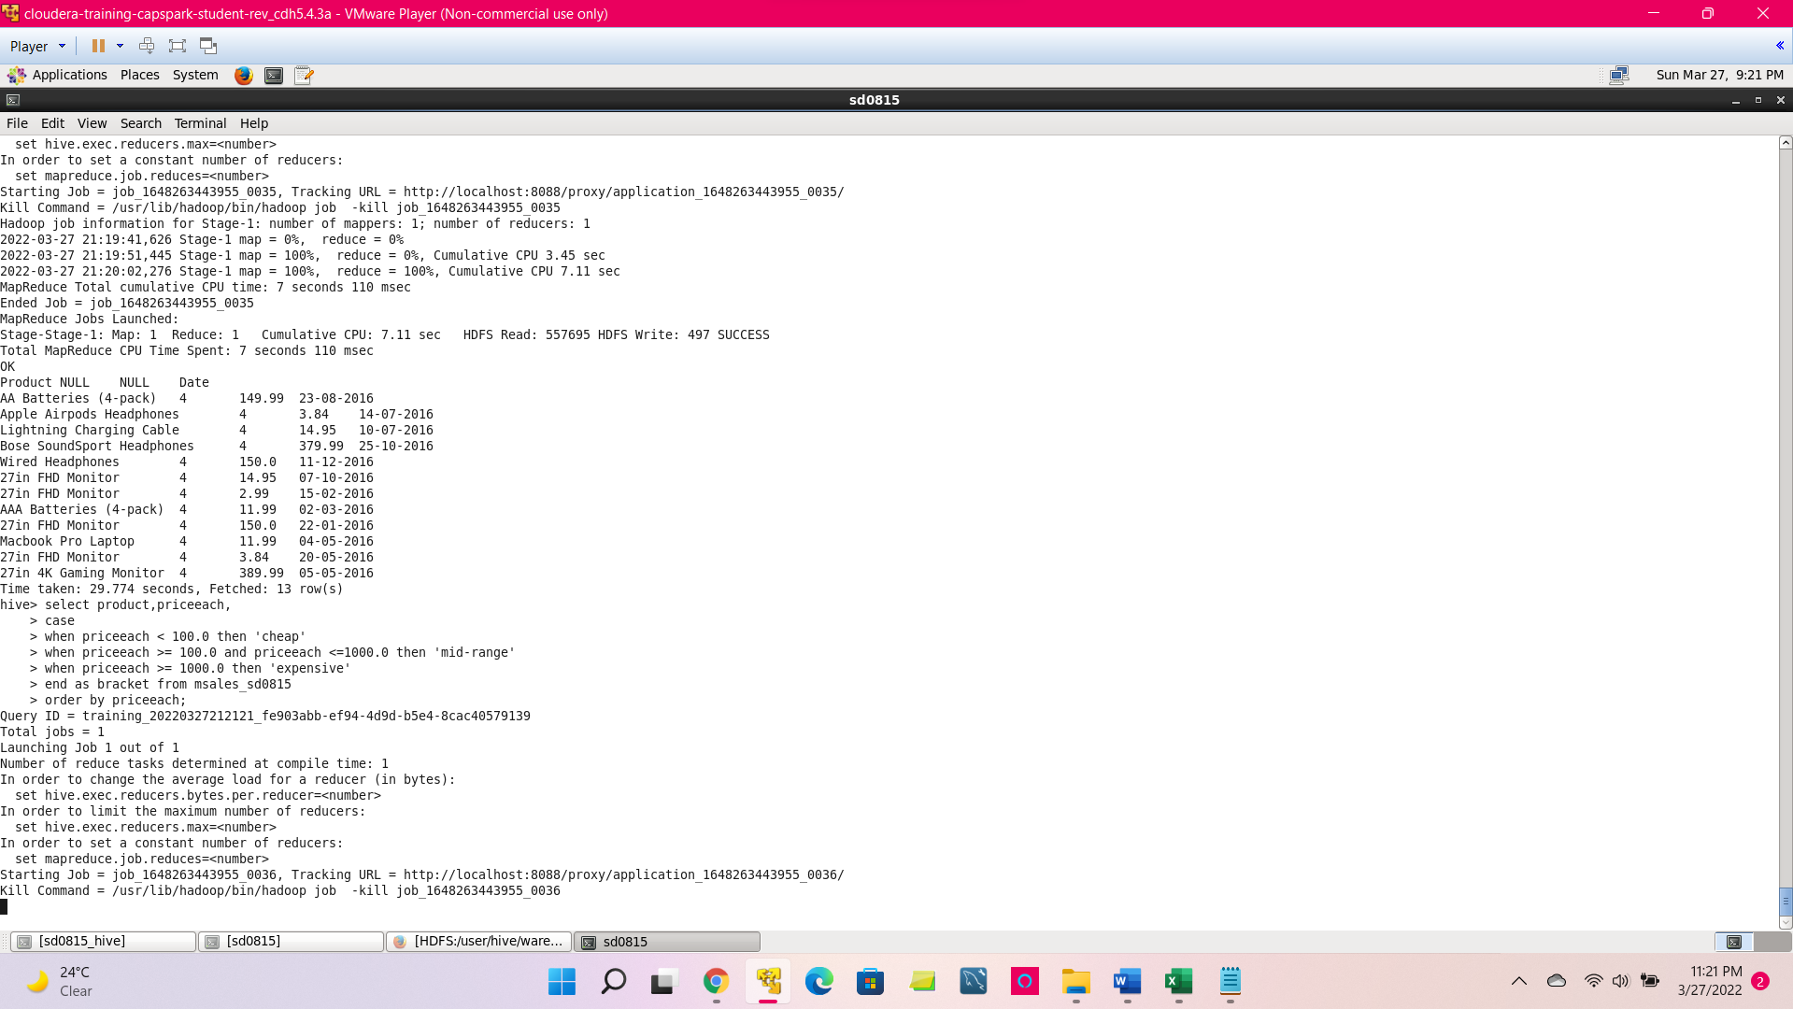

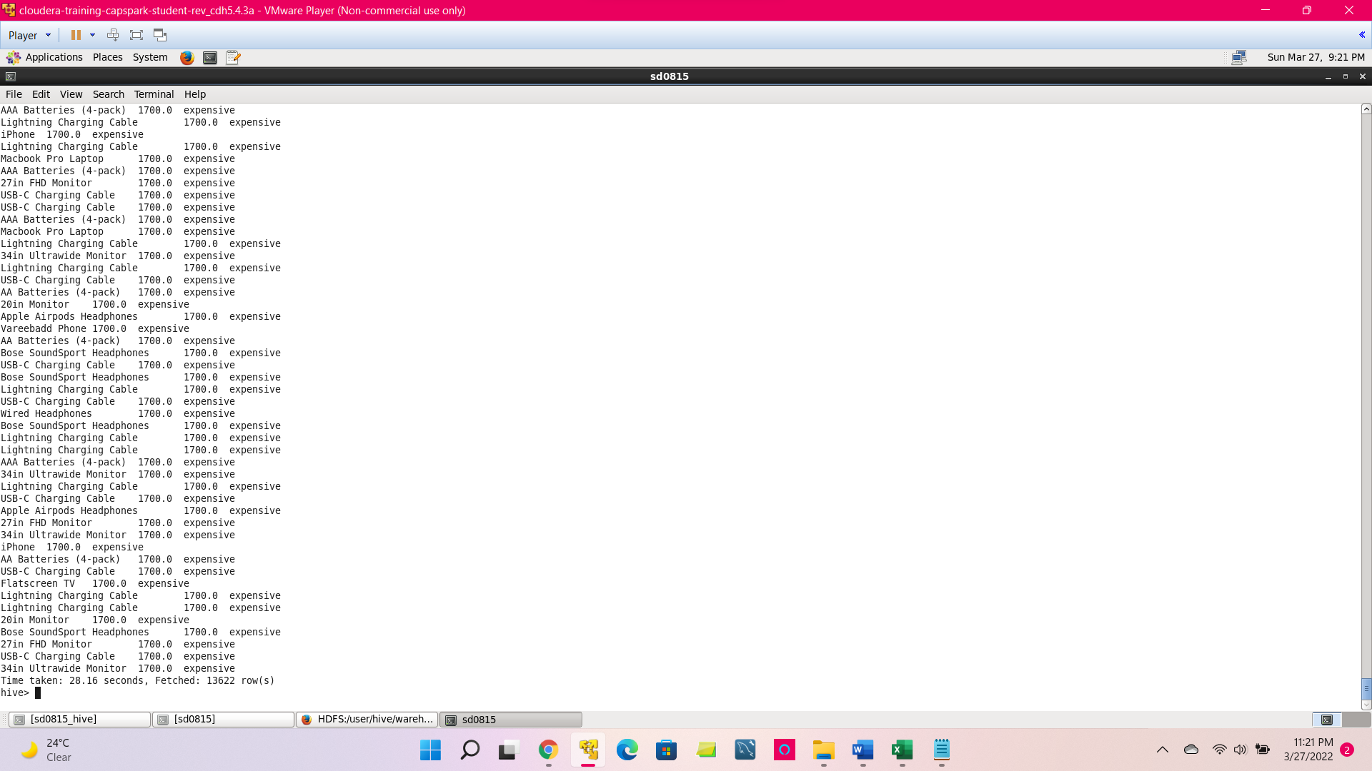

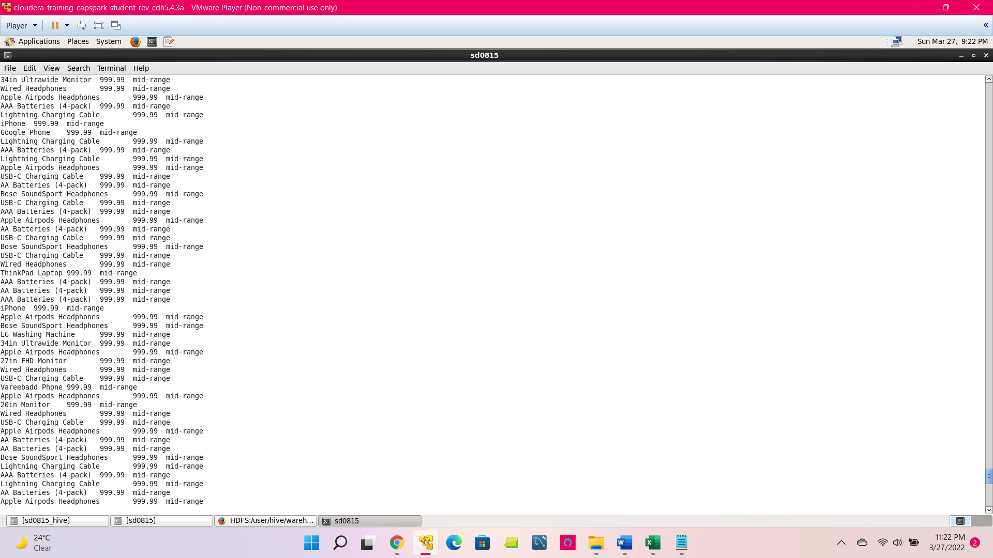

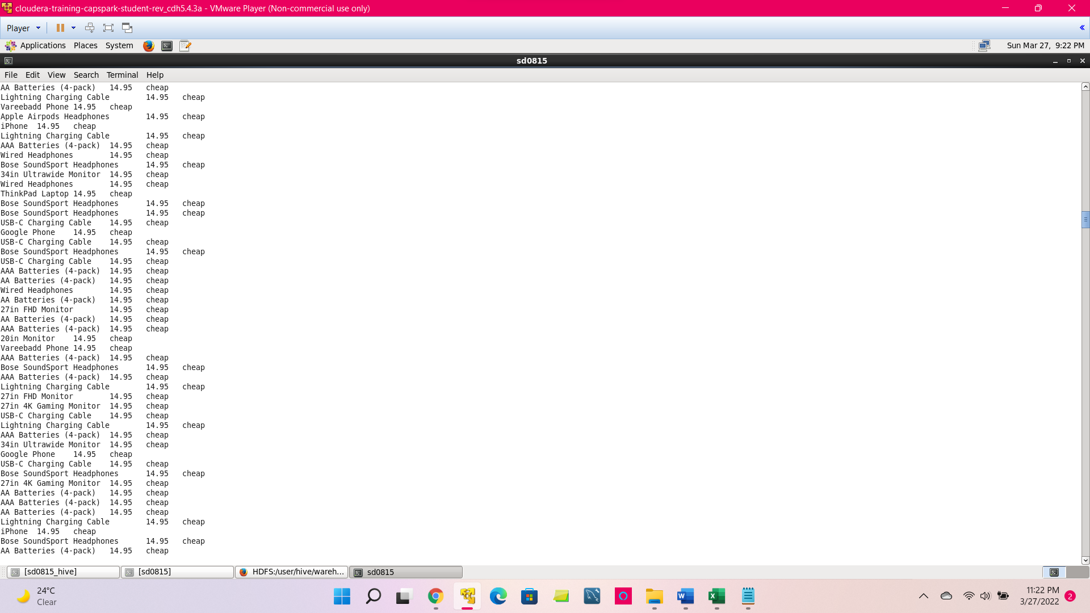

**Question :** You have transformed the Ford company share data in assignment 1. Use the table(s) saved in Hive and import the data into Spark. In Spark, using RDD transformations, create new column ‘Quarter’ in the file and list the top 3 prices in each quarter. Perform this activity in Cloudera? (You may do it has an application or command line)

Solution:

*val hc=new org.apache.spark.sql.hive.HiveContext(sc)*

*import sqlContext.implicits._*

*import org.apache.spark.sql._*

*import org.apache.spark.sql.functions._*

*import org.apache.spark.sql.expressions.Window*

*val fordtxt = hc.sql("select * from ford")*

*fordtxt.show()*

*fordtxt2 = fordtxt.withColumn("Date",to_date($"Date","dd/MM/yyyy")).withColumn("Quarter",quarter($"Date"))*

*fordtxt2.show()*

*val fordtxt3 = fordtxt2.withColumn("QtrRank", rank()*

*.over(Window.partitionBy("Quarter")*

*.orderBy($"Stock Price")))*

*.filter($"QtrRank" <= 3)*

*fordtxt3.show()*

Bonus 2:

*val fordtxt4 = fordtxt3.groupBy("Quarter").agg(avg("Stock Price").as("AverageStockPrice"))*

*fordtxt4.show()*

*val fordtxt5 = org.apache.spark.sql.expressions.Window.orderBy("Quarter")*

*var fordlagdf = fordtxt4.withColumn("RateofChange", round(($"AverageStockPrice"-lag("AverageStockPrice",1).over(fordtxt5))/$"AverageStockPrice"*100,2))*

*fordlagdf.show()*

Import the libraries and upload the ford table into Databricks. Convert the data type of Column Date to date from string and then extract quarter from the Date. Then, use windows functions to partition and rank the table based on quarter and by Stock Price. Then filter all the ranks below or equal to 3. For the bonus question, group the data by quarter and aggregate the average stock price to find the average stock price for each quarter. Then use the lag function to find the previous quarter stock price to find the difference and then multiply by 100 to find the rate of change to the next quarter.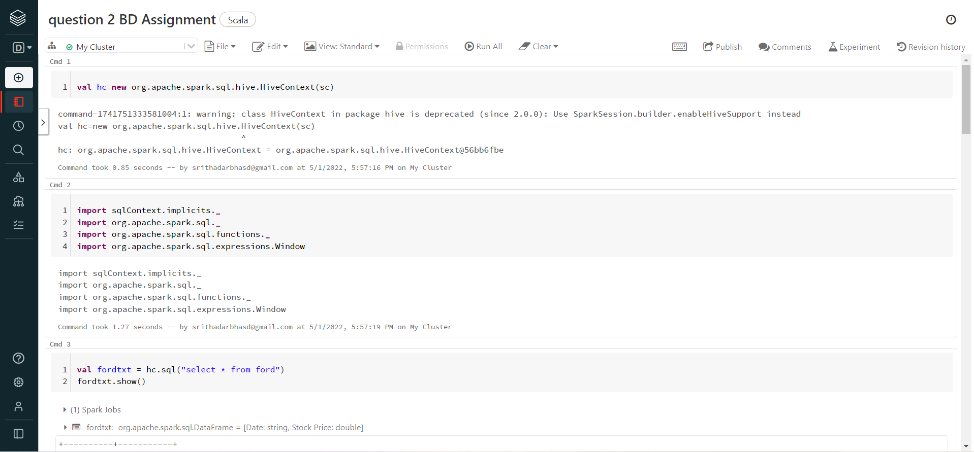

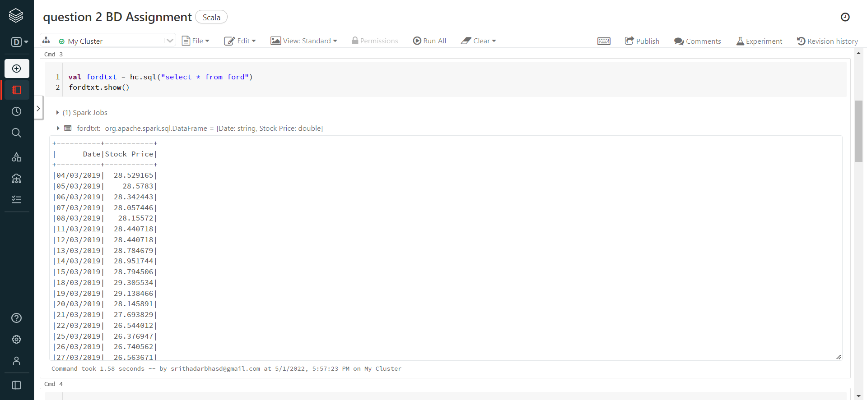

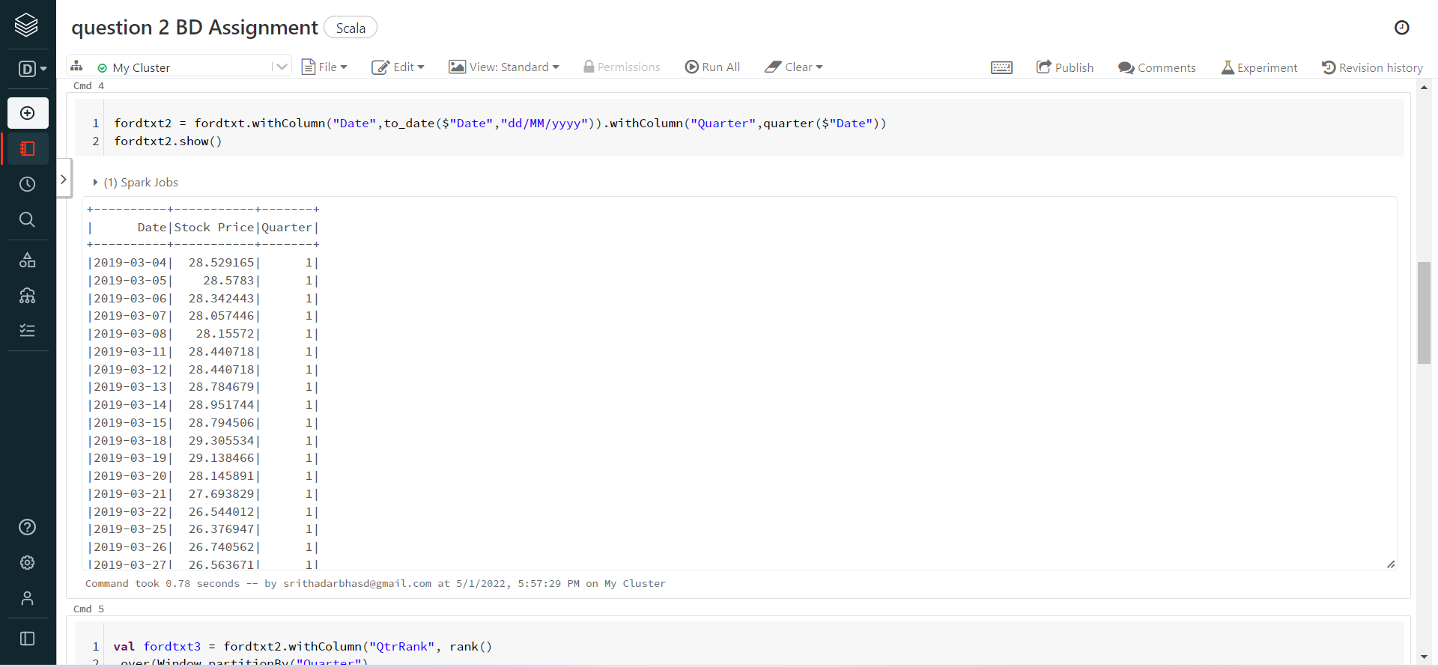

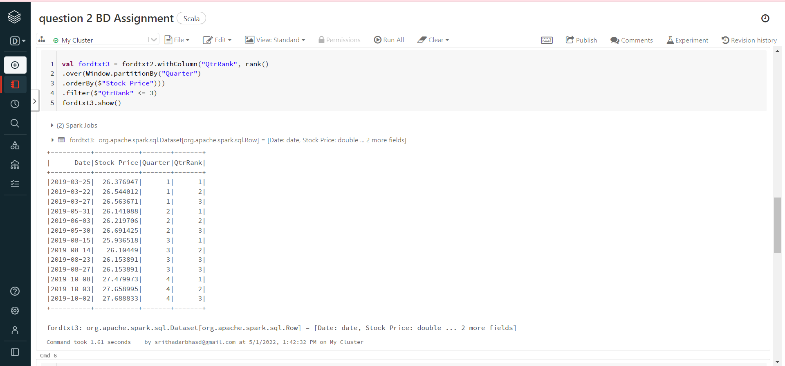

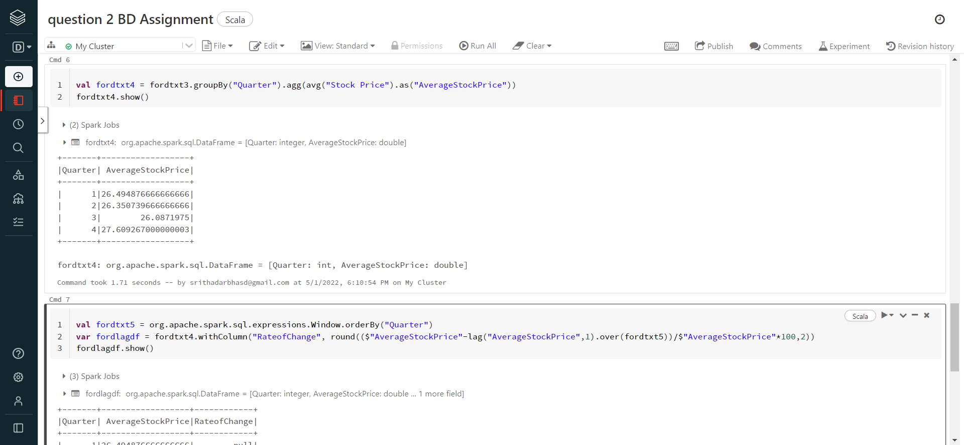

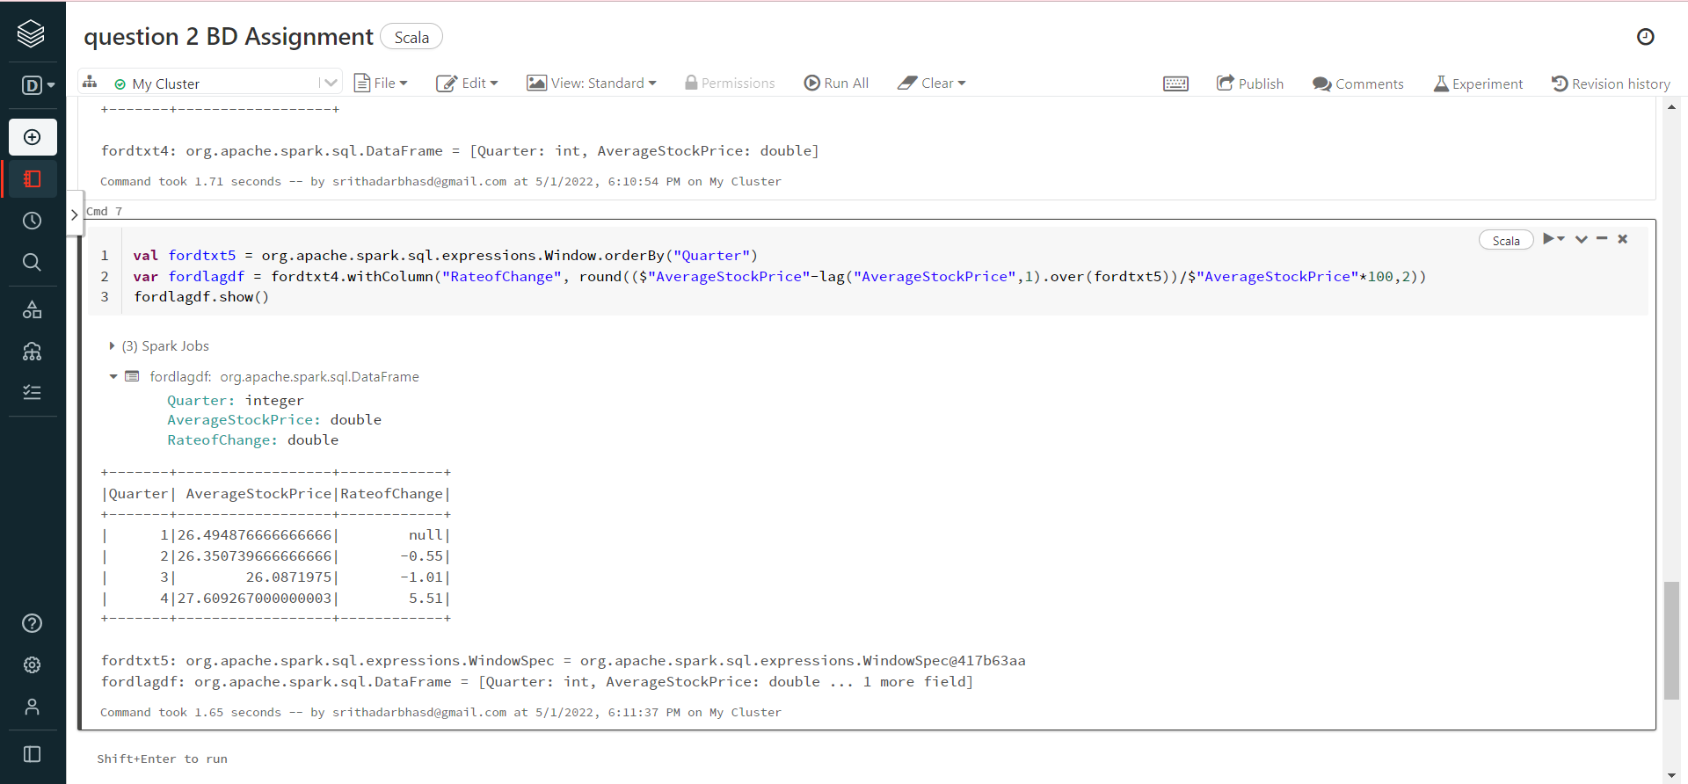

<https://databricks-prod-cloudfront.cloud.databricks.com/public/4027ec902e239c93eaaa8714f173bcfc/3992816840459507/1741751333580990/7611368440882824/latest.html>